SSVM Introduction to Honeybee Medicine

Table of Contents

🐝 What to Wear 1
🐝 Apis mellifera - Honey Bee Species 1
🐝 Honeybee Basics & Terminology 2
🐝 Beekeeing Equipment and Terminology 10
🐝 Honeybee Hive Inspection 14
🐝 Honeybee Diseases and Conditions 20
🐝 American Foulbrood 20
🐝 European Foulbrood 26
🐝 Idiopathic Brood Disease 31
🐝 Varroa Mites and Parasitic Mite Syndrome 32
🐝Honey Bee Viruses 36
🐝Microsporidial Diseases: Nosema Infections 37
🐝 Parasites 40
🐝 Other Health Conditions 41
🐝 Honeybee Nutrition 46

🐝 What to Wear
Closed toe shoes; socks above ankles; long pants light colored bc the brown bear is their natural enemy; long sleeves; no perfumes

🐝 Random Facts
Cannot move a bee hive more than 2 ft because they’ll keep going back to the same location

If bees are missing a queen they will sound different. They will sound sort of angry without a queen and will sound calm with a queen.

🐝 Apis mellifera - Honey Bee Species

Honeybee Breeds – Eversweet Apiaries

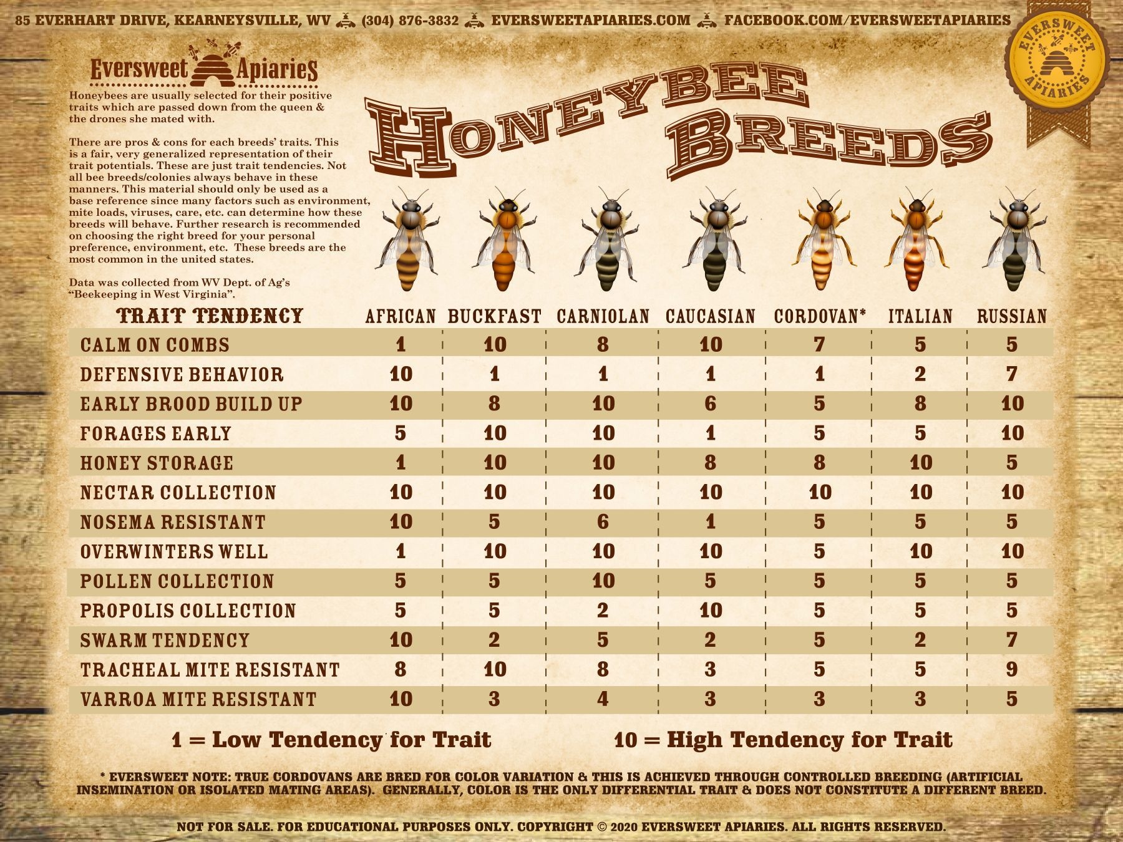
Can get subspecies (mixed breed) Saskatraz are canadian and great at overwintering
OHB Saskatraz Queens - Olivarez Honey Bees, Inc.

These are all European honey bees (Apis mellifera)

They are a superorganism - 10,000 to 80,000 bees per hive

🐝 Honeybee Basics & Terminology
All honey bees in the United States are the same species, the European/Western honey bee (Apis mellifera). They are actually not native to America - they were brought over from Europe.

The hive is made up of a series of Cells

There are 3 types of bees within the colony

Queen
The queen is the fertile female of the hive and is the sole source of fertilized eggs that become worker bees, laying up to 2,000 eggs per day during peak production. The queen is the largest bee in the hive. A colony will only produce new queens when it prepares to reproductively split by swarming, when the old queen has died, or to replace a failing queen. Many queen cells will be created, and the first one to emerge will kill the remainder, and will fight with other emerged virgin queens so that only one remains.

A beekeeper may ‘requeen’ or replace a queen to introduce a younger or better performing queen. A colony can only function normally when a queen is present and laying well. A colony is considered “queenright” when a queen is present, and “queenless” in the absence of a queen.

Bees can requeen themselves

You can make new hives with queen cells - removing them and making new hives can help keep your hive from swarming

Swarming is when half your hive leaves and lives somewhere else. (Might be your neighbor’s yard)

Drones
They have no stinger
Drones are the only male bees in the hive and are haploid (having only one chromosome set) because they arise from unfertilized eggs (queens and workers are diploid because they arise from fertilized eggs). Drones have large, thick bodies – larger than those of the worker bees, but shorter and thicker than that of the queen. Drones perform no functions inside the hive; their sole duty is to search for and mate with virgin queen bees on their mating flights.
If the drone does successfully mate he will die afterwards.
drones are all kicked out of the colony before the winter so they don’t consume precious resources.

Workers
Workers are female bees that perform the vital work of the colony. Worker bees have a variety of functions such as providing for the queen's needs; cleaning cells in the comb, nursing larvae, producing wax and forming it into honey comb, guarding and defending the hive, removing dead bees from the hive, cooling the hive or heating the brood, carrying water, gathering and transporting pollen, gathering propolis and using it to coat the hive, collecting nectar, sealing honey, and scouting for resources. Worker bees are incapable of laying fertilized eggs that can become queens or other worker bees; they are only capable of laying unfertilized eggs that become drones, but this ability to lay even unfertilized eggs is suppressed in the presence of a laying queen. The lifespan of a worker bee varies with the time of year: they may live only 5-6 weeks during the spring and summer, and may live five months or longer during the inactive winter period.

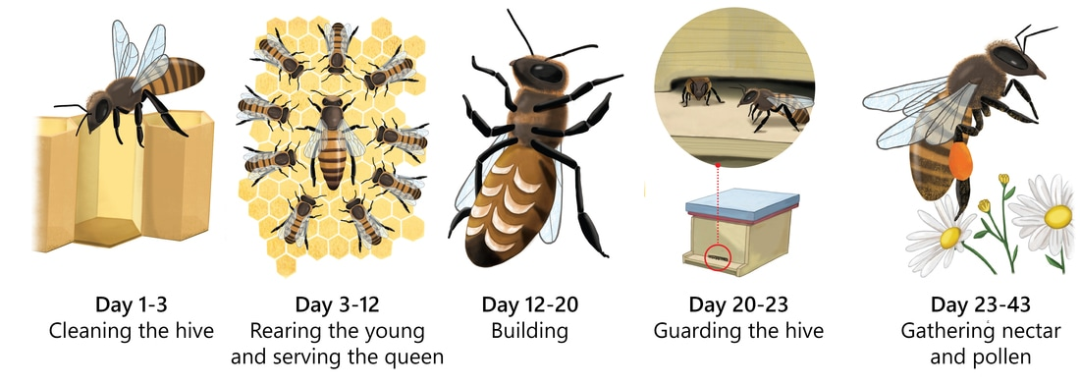

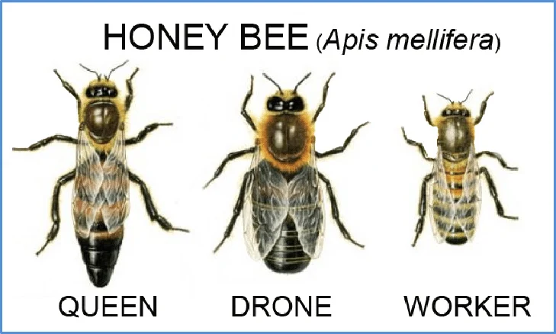

The term brood refers to the young, developing bees - the eggs, larvae and pupae. Bees at this stage remain stationary within the cells of the comb.

After 3 days the egg hatches, and a larva emerges. The larvae are fed and grow over the next 6 days, after which the cell containing the larva is capped (the open top is sealed over by worker bees with porous wax). The larva then matures to a pupa inside the capped cell (capped brood) and eventually emerges from the cell as a bee. The total time spent as brood is 16 days for queens, 21 for workers, and 24 days for drones.

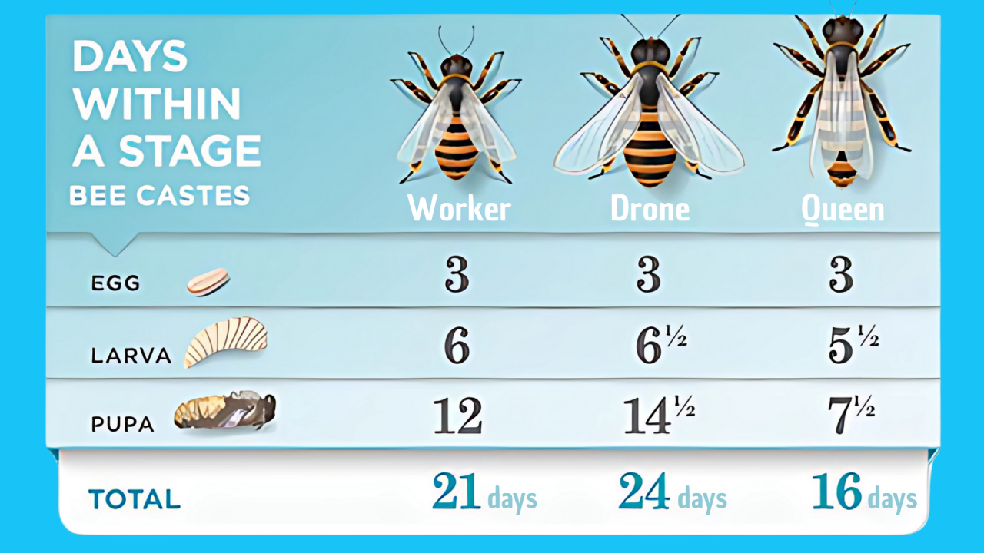

Egg laying ceases in late fall or early winter and in times of stress.

The size and orientation of the cells determine which type of bee along with their diet. Queens are fed entirely royal jelly - others are fed a mix of royal jelly and bee bread.

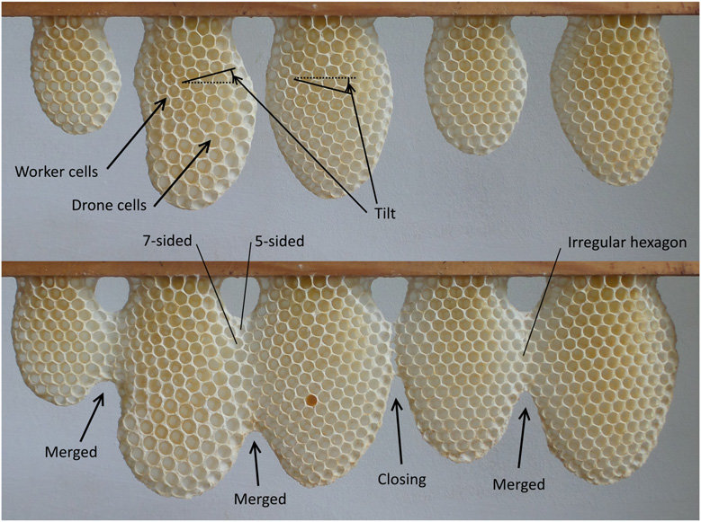

The diet of honey bees is entirely from flowers. Floral nectar provides a source of carbohydrates. Bees prefer to eat fresh nectar when available, but they will store it in cells for when there are no available flowers. To prevent fermentation, the bees dry the nectar to below 18% water content, which then is referred to as honey. Pollen provides a source of protein, vitamins, fats, and minerals. To store pollen, bees will pack it into cells, add nectar, and ferment the pollen into a storable substance called bee bread.

A typical honey bee colony consists of one queen, hundreds of drones (in summer), and tens of thousands of workers. A healthy colony is one where there the queen is laying enough eggs and the workers can raise enough brood to replace the workers that are dying, and there are enough members of each age of worker to perform all the necessary tasks of the colony.

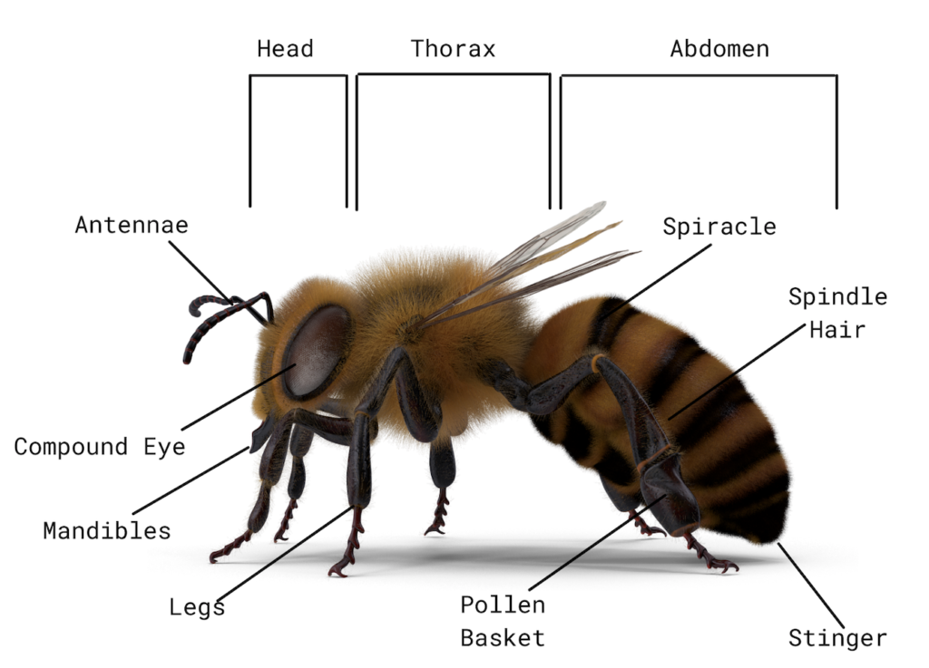

Have eyes on the top of their head in addition to the Compound eye which helps them distinguish light (can see UV). Compound eyes see shape

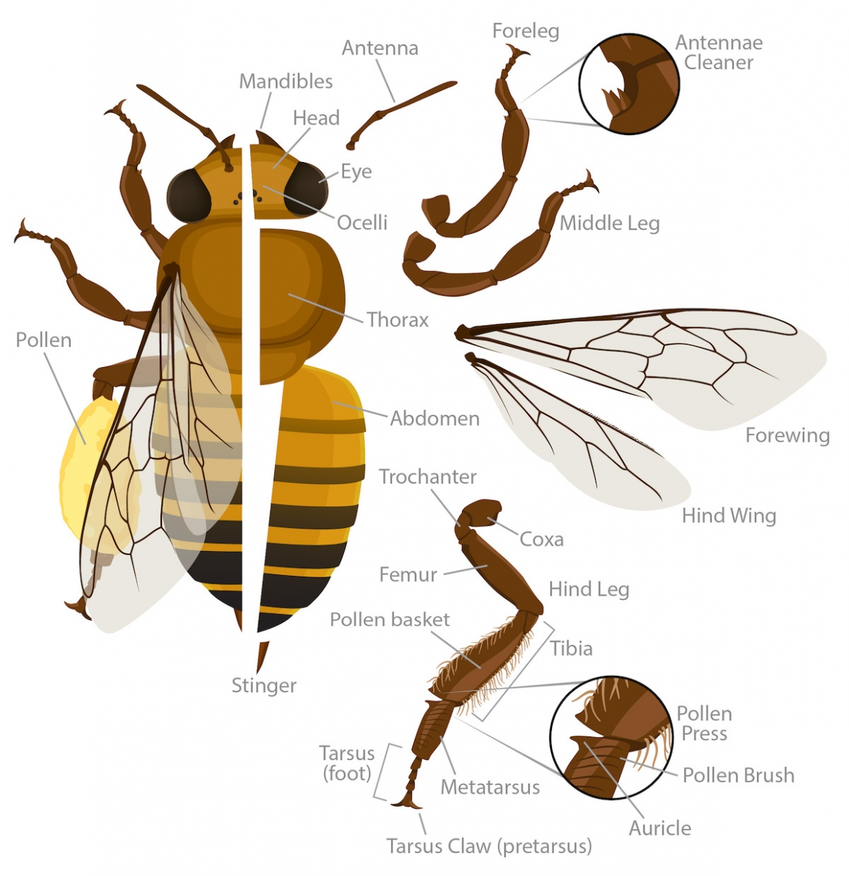

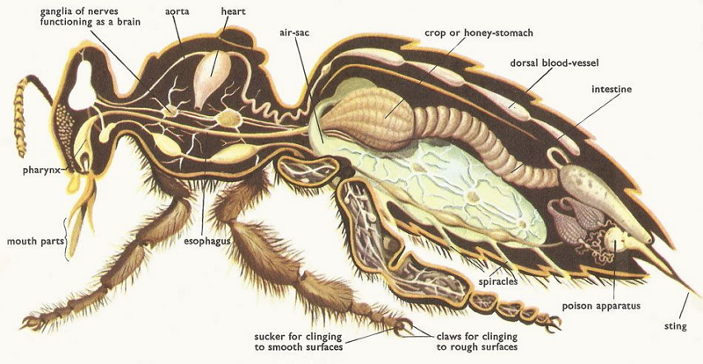
There are also wax glands

As bees walk on the wax it turns from white to yellow - the darker the “dirtier it is”

🐝 Beekeeing Equipment and Terminology

Honey bee products
Although honey is the most widely known product of a honey bee hive, there are a number of other products that can be harvested and sold from the hive: beeswax, propolis, royal jelly, pollen, and honey comb. Many beekeepers also use their colonies to produce bees for sale: queens are sold to re-queen a queenless hive or replace a failing queen; while nucs (nucleus colonies: three to six frames from a hive with workers, brood, honey, pollen, and a queen), packages (2 or 3 pounds of bees with a laying queen), and splits (a portion of the original hive) are used to start new colonies.

The hive
Honey bees are cavity dwellers, commonly living in hollowed out trees in the wild. Honey bee hives all have the same basic characteristics: a dark cavity over 40 L volume, a small entrance, and movable frames where the bees can construct honey comb. Although there are several types of hives used, the Langstroth style hive is the most common in the United States. A typical Langstroth hive consists of the following components: a bottom board (which may be solid or screened); a series of boxes or ‘supers’; and a lid. There are many variations on the standard hive. The boxes come in different widths (8- or 10-frame), and heights (deep, medium, or shallow). Generally the colony lives in the bottom boxes (the brood nest), and excess honey is stored in the upper boxes (honey supers).

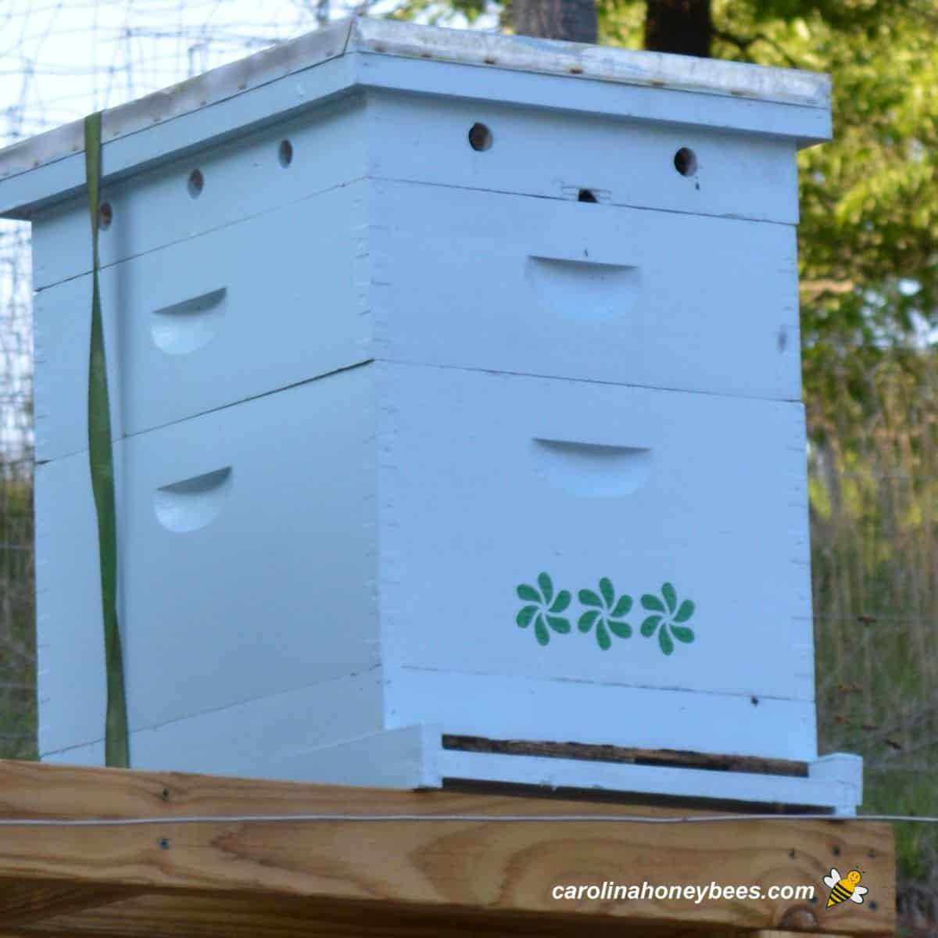

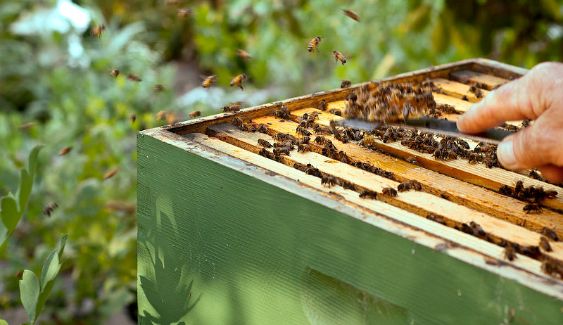

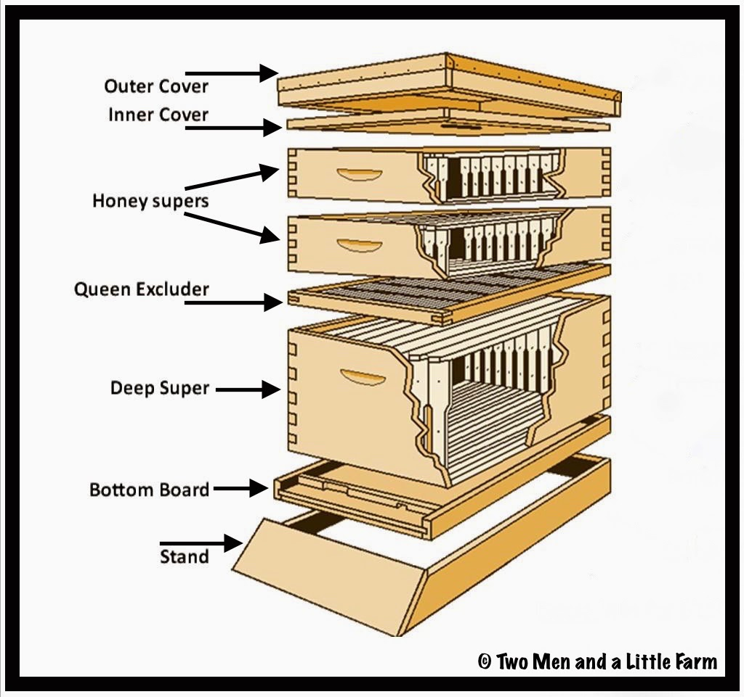

Only good to open hives if its 65 degrees or above

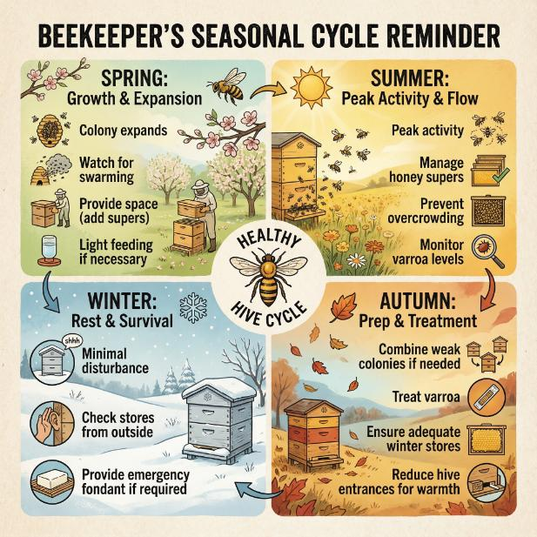

All hives must have removable frames to allow for inspection. The foundation is the central portion framed by the wooden frame. The foundation is a flat piece of beeswax or plastic with the outline of cells embossed into it. The bees will create a comb using the foundation as a base, a process beekeepers call ‘drawing out’.

Deeps which are the biggest boxes and supers for the honey changers run all mediums - run deeps and mediums - need to run at least a medium for brood
Deep, Medium, Shallow - The Boxes of a Beehive Explained.

Beekeeping tools
The main tool used by beekeepers is the hive tool, a pry bar used to pry open the lid, separate boxes, and separate frames for removal. A soft bee brush may be used to gently brush bees from the removed frame to allow examination of the underlying brood. A smoker is used to move bees away from areas to be examined and to calm the bees.

Protection
Protection worn by beekeepers is variable, and may include coveralls (secured at wrists and leg hem); gloves; and a screened head cover with veil. Some experienced beekeepers don’t wear any protective equipment when handling their colonies.

🐝 Honeybee Hive Inspection

Hygiene
When working with a beekeeper, use only their equipment to prevent the transmission of disease between apiaries. The beekeeper should provide a smoker and hive tool, though you should have your own protective gear. Wear disposable nitrile gloves as these will prevent most stings and can be disposed of after use. When you are finished inspecting an apiary, make sure all wax, propolis and honey is removed from your equipment, protective clothing and self. The best way to remove propolis is with the use of denatured alcohol

Inspecting the records
Just as a good history can set the stage for a successful veterinary visit for pets or large animals, it can also provide clues regarding the colony’s overall health and potential problems. Look over the hive records for patterns or sudden changes. If the beekeeper does not have any records, encourage them to keep notes in a journal, on a calendar, or in one of a number of computer applications available.
Common records include the following information:
- Age and source of colony and queen
- Is the queen marked, and has she been recently replaced?
- Recent actions by the beekeeper (treatments, adding equipment, removing honey, feeding)
- Changes in size or activity of hive
- Signs of pests or pathogens, including monitoring for the varroa mite

Examining the hives
Signs of robbing include a much higher rate of activity at the entrance or other holes, fighting bees, and the presence of yellow jackets or other species getting into the hive. Compare hive activity to others in the same yard, keeping in mind that lower activity does not necessarily indicate a problem.

lower activity could have to do with a recent requeening or split.

When you are near the hive, avoid swatting or agitating the bees. Bees will not be interested in stinging you unless you agitate them or injure or kill a bee. Try not to block the entrance to the hive, as you increase the chances of problems with the bees by blocking their path of travel. Always stand off to the side, or behind the hive, and move slowly.

Once the hive is open, note the location of and general size of the colony, known as the cluster size. Cluster size is generally estimated in ‘frames of bees,’ where a frame is counted if both sides of the frame are covered with bees. The cluster should generally fill the boxes, and should be similar for hives that are managed the same way. A small cluster may indicate a health issue, while lack of a well-defined cluster may indicate a queenless colony, or that too much smoke was used.

You will need to see into the brood nest to identify if the colony is healthy. The beekeeper will remove any honey supers that are present to allow you to go down into the lower part of the hive. Ask the beekeeper to remove as many frames as necessary to get a good assessment of brood quality. The presence of eggs, larvae, and capped brood indicate a healthy queen and colony. Look at the color, consistency, and pattern of the stages in the frame.

Note that the cells of the comb are not flat from front to back; they slope downward toward the foundation, as shown in Image 9. To fully inspect the cells, hold the frame at the top bar and angle it slightly to allow you to view the base of the cells. It is often necessary to view the cells with the sun over your shoulder (face directly towards the shadow of your head) or to use a flashlight to see the bottom of the cells and to view eggs. In order to inspect the brood, hold the frame perpendicular to your line of sight.
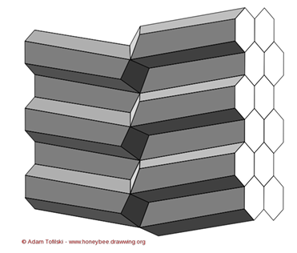
Adult bee health
As you work through the hive, look at the adult bees. They should be large and uniform. Signs of disease in adult bees include stunted growth; shiny, hairless bodies; deformed wings, or wings held out at odd angles; or weak, trembling behavior. The workers should be highly active, and moving throughout the hive

Brood Health
A healthy brood should be very consistent in both appearance and position on the frame. In a healthy colony, brood around the same age are near each other with few gaps. Disease or issues are indicated by gaps or inconsistency in the appearance of the brood. Generally, the queen will lay in concentric circles – brood of the same age will be in rings radiating from the center of the frame. Normal eggs are white in color and upright in the cell. They are attached to the center bottom of the cell. Abnormal positioning of the eggs, including multiple eggs per cell can indicate that the queen is absent and workers have started to lay drones, a terminal condition for the colony. In Image 11, the white eggs are clearly visible against the black of the foundation. Eggs may be difficult to see, so lighting is critical. Some beekeepers will use magnification to see eggs and very young larvae

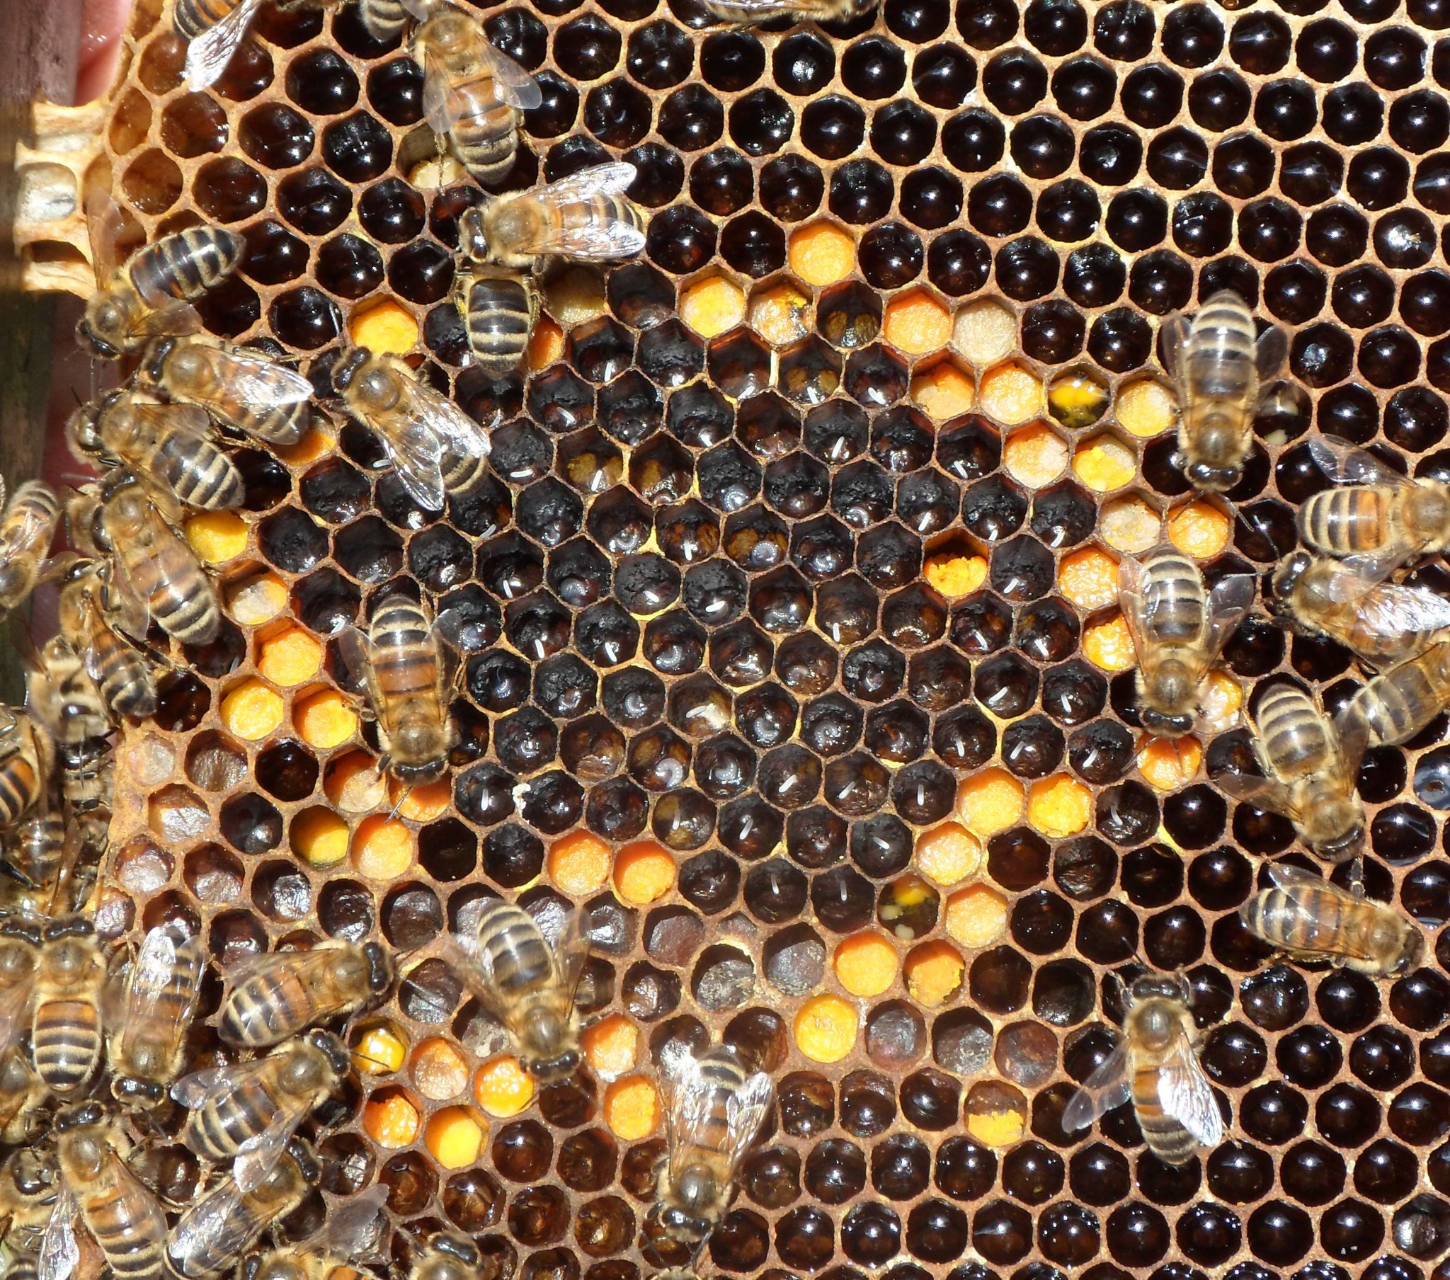

Healthy larvae are pearly white in color, plump and glistening, and form a “C” shape in the cell. In image 12, the larvae look healthy because they are white, uniform and lying in large pools of royal jelly. When the larvae first emerge from the egg, they are about the size of the egg and lie in a pool of royal jelly. The larva grows quickly, nearly filling the bottom of the cell before it is capped.

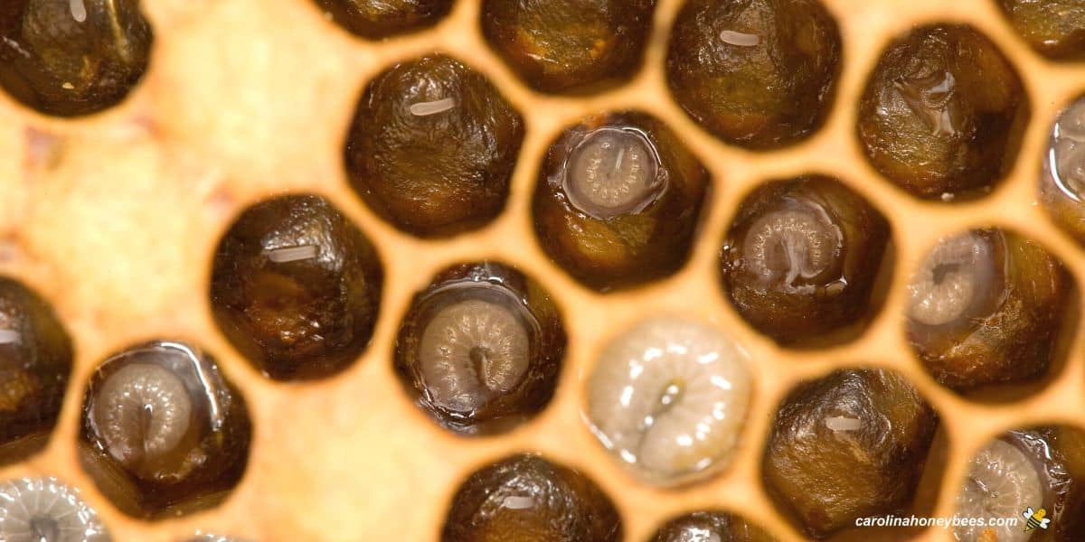

Normal, healthy capped brood (pupae) has a soft, papery looking capping and can that can change from yellow to brown as they age and as the frame is reused. Worker brood is flat to slightly raised, while drone brood tends to be raised (bullet shaped). The capped brood should be very consistent, with many of the same age all together, with few spaces in between cells. A small amount of patchiness (inconsistency) is acceptable, but spotty, “shotgun” patterns and heavy patchiness indicate a brood problem.

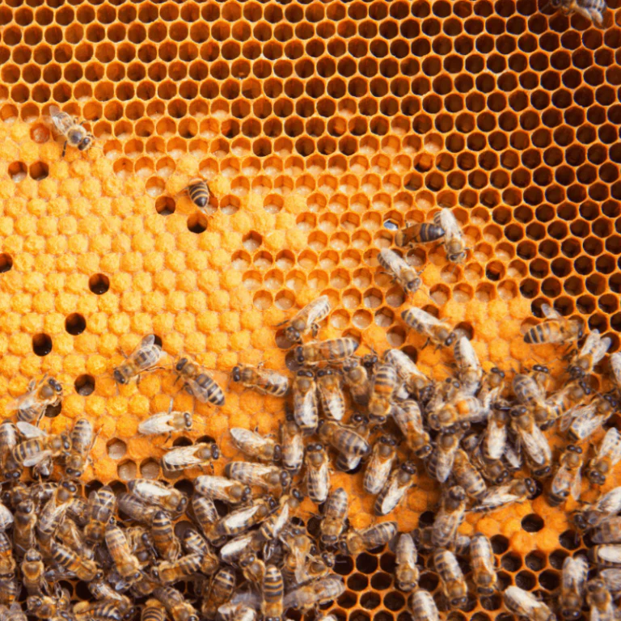

Nutritional Assessment
Colony health is strongly associated with its nutritional status, which is predominately a function of the amount and quality of incoming pollen. Check to see whether there is a band of stored pollen in an arc above and to the sides of the brood. A 1” arc of bee bread of multiple colors is optimal; a narrower arc, or bee bread of only one color, may indicate a food dearth. A colony should have excess stored nectar/honey and pollen at all times.
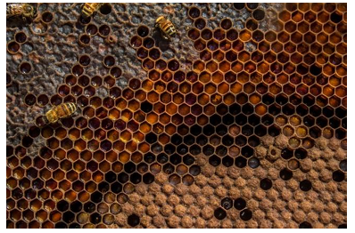

The easiest and most direct assessment of nutritional status is to see how much jelly the workers are placing around young larvae.

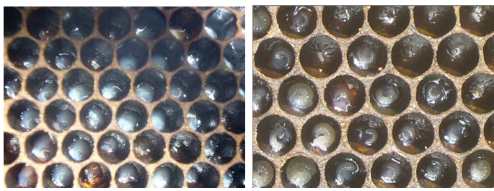

Image 1) Well-fed larvae, as indicated by the ample royal jelly covering the entire bottom of the cell. This colony will likely be in good health.

Image 2) Poorly-fed larvae, as shown by the dry bottoms of the cells (the nurse bees are forced to restrict the amount of jelly being fed). This colony is suffering from nutritional stress, and is more susceptible to pathogens.

Queen Cells
are immediately recognizable because of their size and perpendicular orientation to the ground (they point towards the earth, while worker and drone brood lie horizontally/ parallel to the ground). Queen cells may indicate that there is an issue with the current queen; that the queen was killed and is being replaced; that the colony is large/crowded and will soon swarm; or they may indicate nothing – sometimes the bees make them, and later tear them down. Queen cups, which look like wax bowls facing down, are not the same as queen cells. Cups are present in the hive throughout the year and are the base for queen cells.

If you see eggs, you know the queen has been there within the last 3 days. .

Capped queen cells - they are making a new queen; try to see if you can find the queen
If queen cells are in the middle of the hive it typically means they are superseding the queen.

Hives will not swarm unless the have a capped queen cell

If you have more than two eggs per cell you either have a new queen or a laying worker. A laying worker will lay drones and this will collapse a hive. You pretty much have to shake out all of the bees and start over. The bees will keep rejecting queens because they think they have a laying queen. And it's impossible to find the laying worker. If that worker dies another worker will take over laying. Sometimes if you shake them out far away from the hive the healthy workers might find their way back but not the laying worker.

🐝 Honeybee Diseases and Conditions

Only two honey bee diseases, however, are commonly treated with antibiotics, therefore requiring veterinary oversight: European foulbrood (EFB) and American foulbrood (AFB).

The “foulbrood” name originated due to the foul smell arising from the
decay of the infected brood, but American and European foulbrood are not closely related.

🐝 American Foulbrood
Caused by Paenibacillus larvae, a spore-forming bacteria that
generally only affects the pre-pupal and pupal stages of development. The vegetative, infective state of the bacterium is susceptible to oxytetracycline, lincomycin, and tylosin. The spores formed by the bacterium are not affected by antibiotics, are resistant to temperature changes and chemicals, and can live in honey and persist in the environment for up to 70 years.

American Foulbrood Diagnosis: Visual Inspection
- Foul odor - The odor is something between decomposing adult bees and old gym socks. May be able to smell from a few feet away from the colony entrance.
- Shotgun brood pattern - The first sign consistently observed with any disease affecting the brood is a spotty (or “shotgun”) pattern of the brood cells. This is indicative of brood disease, but is not pathognomonic for foulbrood. This indicates that brood are dying before they are capped.
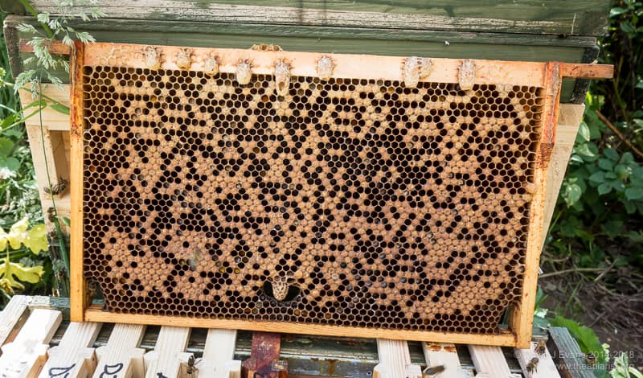

- Perforated caps - AFB-affected cells develop sunken, discolored caps. The caps develop a sunken, dark, and “greasy” appearance as they liquify. Perforated caps can be distinguished from incomplete caps by appearance and location of the hole. Healthy, incomplete caps have a clean-edged, central defect that will be filled if inspected again later, while perforations have irregular edges and may or may not be centrally located.

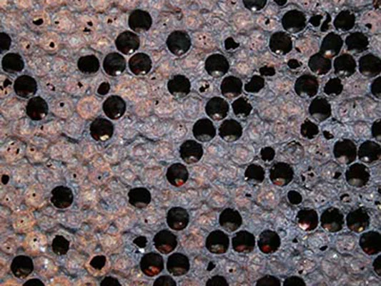

- Larval scale - As AFB-infected larvae die, they tend to melt flat against the bottom wall of the cell (towards the ground). As they dry, they can form a scale that is visible at the bottom of the cells. Other diseases such as EFB form scales, but AFB scales are much harder to dislodge; removal of AFB scales often results in damage to or destruction of the honey comb. To inspect for signs of AFB scale, hold the frame horizontally.
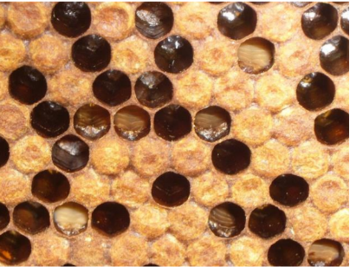

Note the black, raised scales lining the bottom wall of several cells, as well as the sunken, perforate caps.

- Pupal Tongues - AFB kills young bees at a specific developmental stage, and they sometimes die in a characteristic manner, with the developing proboscis exposed, referred to as the ‘pupal tongue.’ The presence of pupal tongues is characteristic of AFB, but the absence of pupal tongues does not rule out the disease.
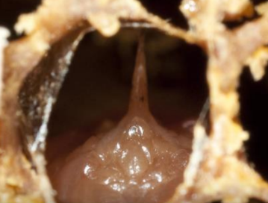

- Matchstick / rope test - A positive rope test (also called matchstick test) is characteristic of AFB. To perform the test, insert a matchstick, toothpick or similar object into a cell with a discolored oozing cell cap and then slowly pull it out. The decaying products in the cell will form a viscous string from the tool and will rope out 2 cm or more. A negative rope test does not rule out AFB, because the larvae must be in an appropriate stage of decay. A positive rope test is characteristic of only AFB. Other diseased larvae may look similar, but will rope only slightly or be removed as a blob, and will not string to 2 cm. 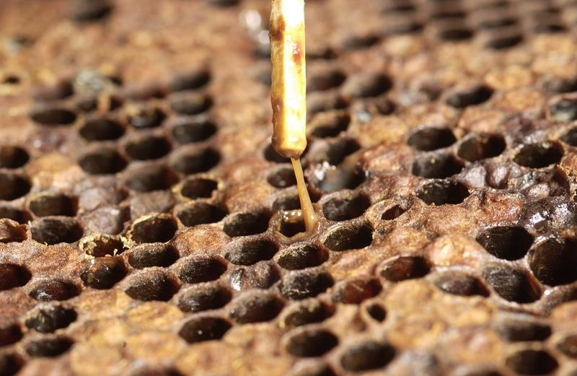

- The Holst milk test - Use two test tubes of highly diluted milk. Add a scale or infected larvae (or the contents of the rope test) removed from an affected cell to one of the tubes. The other tube will serve as a control. Incubate the tubes in your pocket or a warm cup of water for 10-20 minutes, occasionally stirring or shaking both tubes. If the opaque milky fluid in the diseased tube changes to a transparent, brownish fluid this is suggestive of AFB. A negative test doesn’t rule out AFB as the larvae must be in the appropriate stage.
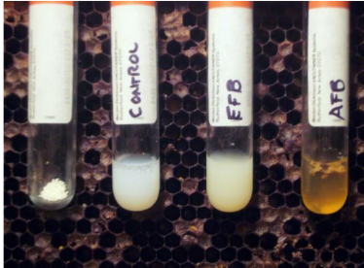

- Field ELISA test - Vita Europe makes an AFB diagnostic test kit available in the U.S. from most bee supply companies.

Suspect American Foulbrood if the following signs are present
- Shotgun / patchy brood pattern
- Dying pre-pupae or pupae melting against cell wall
- Capped cells are sunken, discolored, and perforated
- Brown liquid at bottom of cells or oozing out of cap
- Hard-to-remove scales found on bottom of cells
- Can have foul-smelling odor (also seen with EFB)
- Presence of pupal tongues
- Dying larvae or rope caramel colored
- Positive rope test
- Positive Holst Milk test
- Positive field ELISA test

American Foulbrood: Treatment
In many states, AFB may be considered a reportable disease, and state apiary law may require destruction of infected colonies. Make sure you communicate with your state apiarist and are aware of state laws regarding American Foulbrood.

Treatment for AFB should occur if even a single infected cell is identified in a colony. Carefully
inspect all other colonies in that apiary, being extra cautious about cleaning hive tools and
switching gloves as you pass from one hive to another.

Many states require that a colony diagnosed with AFB be destroyed immediately; The most common method of destruction is burning the hive, but gamma irradiation will also kill AFB spores and may be an available option.

Even if burning the hive is not required in your state, it is recommended because it can fully halt infection and prevent spread of the spores.

In areas that do not allow burning or where it would be imprudent to burn a hive, it may be necessary to have the bees killed and the hive boxes put in bags, and then transported as a unit to where they can be burned. Polystyrene and plastic
frames may pose environmental risks when burned, and deep burial or irradiation may be indicated.

Once AFB is diagnosed, hive entrances should be screened and any cracks, holes or other egress points should be sealed with tape; this may be more easily accomplished during periods of low bee activity, such as nighttime, rain, colder temperatures, and very early in the morning. Prior to burning the hive, the bees should be depopulated using methods that comply with all regulatory requirements.

🐝 European Foulbrood
European foulbrood (EFB) is caused by Melissococcus pluton, a non-spore-forming bacteria, but infection is associated with a variety of bacterial strains. EFB only affects the honey bee larval stage and is more contagious than American foulbrood (AFB). It more commonly affects stressed colonies, and may resolve spontaneously if stress is reduced and honey bee health is improved.
It is less severe than AFB, but can still cause devastating brood loss. In recent years, EFB has shifted its pathogenicity in the U.S.; it no longer spontaneously clears with the advent of a good nectar flow, and EFB infection is likely to persist in the hive.

Can only be treated with antibiotics prescribed by a veterinarian

European foulbrood diagnosis: visual inspection findings
- Spotty brood pattern - Similar to AFB and other brood diseases, brood infection with EFB will exhibit a spotty brood pattern as larvae perish, and the healthy pattern of brood is disrupted.
- Larval discoloration - EFB tends to only affect older larvae. Causes them to discolor (yellow or gray) and lose their glisten. The trachea become apparent, looking like an internal skeleton of the larvae. EFB is often found with a variety of bacteria so it's common to see twisted, yellow, and gray larvae together in the same frame. Drone brood may be the first to show signs of EFB, so be sure to check drone larvae first if present.
- Larval deformation - infected larvae often assume a twisted or corkscrew position as they die. Sometimes the larvae have a melted appearance as they die and decay, or may look deflated or malnourished when infected.

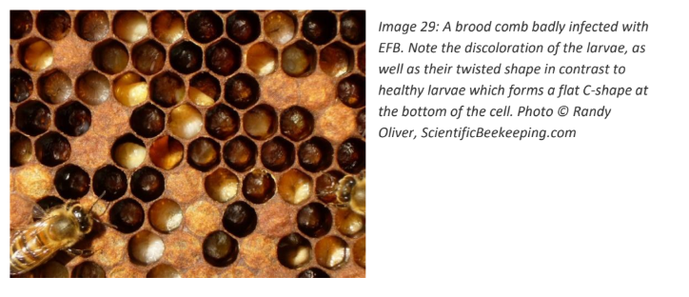

- Yellow brood food - The royal jelly / brood food mix surrounding healthy larvae should be pearly white. In EFB colonies, one of the first signs of infection is often a yellowing of the food
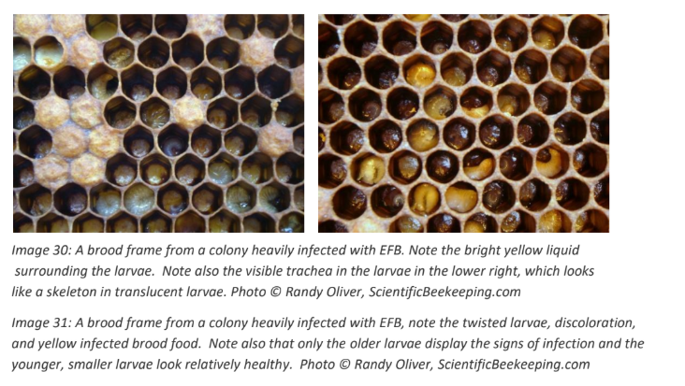

Suspect European foulbrood if the following signs are present:
- Shotgun / patchy brood pattern
- Poor colony buildup in spring - diseased larvae may be difficult to detect without thorough inspection
- Discolored larvae (yellow or brown)
- Twisted or corkscrew - shaped larvae
- Visible trachea in larvae
- No scale is formed - the dead larval bodies are easily removed
- Often a “sour milk” odor
- Yellow royal jelly around larvae

European foulbrood field testing:
A commercial field test is available for the diagnosis of EFB. Because EFB shares many visual similarities with American foulbrood (AFB), EFB should be among the differential diagnoses when the signs of AFB/EFB are observed but the characteristic tests for AFB are negative.

Samples should be sent to the USDA Agricultural Research Service (USDA-ARS) laboratory in Beltsville, Maryland.

How to send brood samples:
- Comb sample should be at least 2 x 2 inches and contain as much of the dead or discolored brood as possible. NO HONEY SHOULD BE PRESENT IN THE SAMPLE.
- The comb can be sent in a paper bag or loosely wrapped in a paper towel, newspaper, etc. and sent in a heavy cardboard box. AVOID wrappings such as plastic, aluminum foil, waxed paper, tin, glass, etc. because they promote decomposition and the growth of mold.
- If a comb cannot be sent, the probe used to examine a diseased larva in the cell may contain enough material for tests. The probe can be wrapped in paper and sent to the laboratory in an envelope.

Even if you are certain of your diagnosis for AFB, and you are practicing in a state without a mandatory reporting requirement, it is important to provide accurate national incidence

European foulbrood Treatment
Oxytetracycline and tylosin have both been used to treat European foulbrood (EFB), however, oxytetracycline is the only drug FDA approved for EFB.

Many beekeepers feel that tylosin is not effective, and most chose to use oxytetracycline. Beekeepers also report that EFB disease may resolve without treatment, although this seems to occur less often than previously reported.

Stress reduction, including feeding, and re-queening the colony, may aid this process. If the infection is not severe (less than 10% of the brood is infected), the beekeeper may choose to employ watchful waiting, where the infected frames are marked and the colony is re-inspected in a week or so to identify if the infection is spreading or improving.

In severe infections, it is often recommended to remove frames with diseased brood, and replace them with new comb in addition to treatment with antibiotics.

Since the bacteria that causes EFB does not have a spore form, frame and equipment destruction is not required; following several months of storage or sterilization with a bleach solution, the frames can be reused.

Many beekeepers would choose to destroy equipment, or set them aside for a season, sterilize them or clean with a bleach solution, before reusing equipment from infected hives.

The water soluble forms of oxytetracycline, tylosin and lincomycin are available for use in honey bees by prescription.

With any antibiotic use, make sure records are kept of the dates of treatments, drug, dosage, prescribed withholding time, and identity of the hives.

For treatment of EFB or AFB, oxytetracycline can be mixed with powdered sugar according the labeled instructions and applied to the top of the frames of the brood nest following the dosage and timing on the label. Dusting of uncapped brood cells has been reported to cause death of larval honey bees. Do not dust uncapped brood cells. Oxytetracycline can degrade rapidly when used in a sugar syrup. Therefore, a fresh syrup solution should be prepared daily.

Antibiotics should be fed early in the spring or fall and consumed by the bees before main honey flow begins to avoid contamination of production honey. Remove at least 6 weeks prior to main honey flow. Due to the potential for residues in honey, it is recommended that tylosin only be used in the fall and not in the spring. Furthermore, tylosin should only be used according to directions as a powdered sugar mixture immediately after mixing. Honey stored during medication periods in combs for surplus honey should be removed following final medication of the bee colony and must not be used for human food. Honey from bee colonies likely to be infected with foulbrood should not be feeding other colonies since it may be contaminated with spores of foulbrood and may result in spreading the disease. Do not use in a manner contrary to state apiary laws and regulations. Each state has specific regulations relative to disease control and medications.

Diseases that look similar to European and American Foulbrood
Idiopathic Brood Disease and Parasitic Mite Syndrome. These may not require antibiotics. The specific etiologic agents of these two diseases remain unknown, although it’s thought they are caused by multiple viruses and can be found in the presence of secondary bacterial infections.

🐝 Idiopathic Brood Disease
Also referred to as “snot brood” and display a host of signs that overlap with both AFB and EFB

Idiopathic Brood Disease Visual Inspection
- Brood may be melted, twisted, and can form scale
- Pupal cappings are often perforated or sunken
- Larvae can darken to a brown color similar to AFB
- Larvae might appear white and gummy but can turn dark gray and even form a loose scale larger or looser than AFB
- Common to see perforated cappings that may be oozing with dark liquid indicating dead pupae or prepupae underneath
- Pupal tongue is not present
- Will not rope with a match stick test. The dead pupae generally will come out in a clump. Some rope might form but not nearly as much as AFB

Suspect Idiopathic Brood Disease if the following signs are present:
- Shotgun / patchy brood pattern
- Larvae may turn yellow but retain “C” position
- Larval death in propupal stage - sticking straight up parallel to the cell
- Larvae may appear melted and gummy
- Larvae eventually melt into dark grey
- Perforated cappings
- May for a loose scale
- Often a foul odor but different from EFB and AFB

Idiopathic Brood Disease Treatment
- Many beekeepers report an improvement in colony health after a course of antibiotics. Others report no improvement after antibiotics. Some have spontaneous improvement
- Many beekeepers have reported an association of IBD and exposure to some insecticides and fungicides
- Removal of diseased frames, breaking the brood cycle (by preventing the queen from laying eggs for several weeks)
- Requeening

🐝 Varroa Mites and Parasitic Mite Syndrome

Varroa mites are the #1 killer of honeybees. The mites feed on the hemolymph and fat cells of the bees. They target larvae that are about to be capped, and move to the bottom of the cell and feed off the larva once the cell is capped.

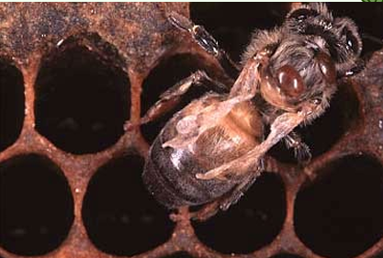

The mites mate inside the cell and mature; once the bee emerges from the cell it will have female mite offspring on it. The mites can cause larval or pupal death and can transmit deformed wing virus, acute bee paralysis virus, Israeli acute paralysis virus, slow bee paralysis and other pathogens.

Affected larvae may spiral up the cell, eventually curling around the opening of the cell in a half-moon shape.

If they are visible on the top of the bee this is a huge infestation!

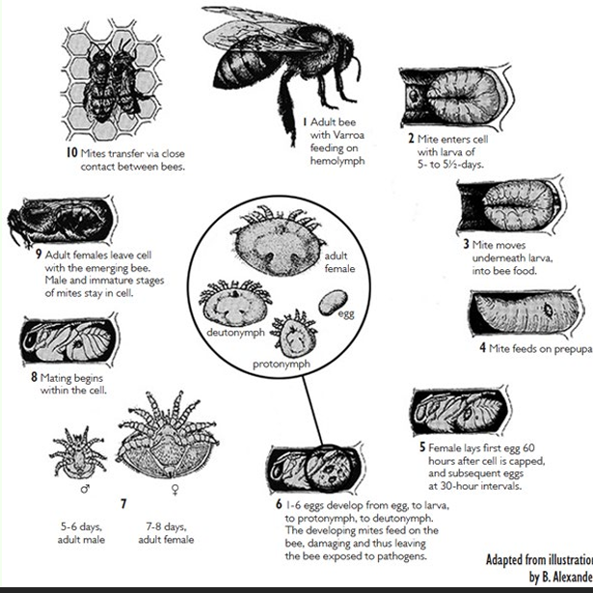

Drones take longer to develop which is why Varroa prefers these cells.

Controlled with frequent mite checks, physical, mechanical, chemical mite control.

Powdered sugar roll - take half a cup of bees and place them in a container of powdered sugar, seal them up, and shake them. Release them back into the hive and the other bees will clean them.

Alcohol wash - take half a cup of bees and drown them in alcohol. This will kill them, but you can count how many varroa come off. Can help determine treatment

You can have specific drone brood combs which then you can remove to eliminate most varroa mites. Take the comb out and put it in the freezer for a few days - feed it to the chickens, clean it off, and place it back in the hive.

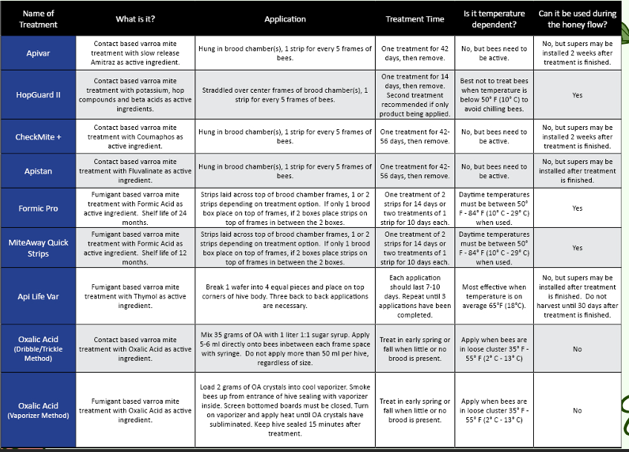

Bees won’t build up a resistance to Oxalic Acid, but its not great as a sole treatment (unless you’re treating every month).

Parasitic mite syndrome (PMS) is caused by viruses transmitted by the varroa mite. In a severely mite-infested colony, bees may express parasitic mite syndrome.

Often in late season.

Deformed wing virus is likely one of the major pathogens causing disease in PMS.

Parasitic Mite Syndrome Diagnosis Visual Inspection
There are many signs b/c mites carry multiple viruses.
- Chewed pupae and melted larvae - spotty brood pattern with the presence of chewed pupae, which may have brown or black spots as they begin to decay.
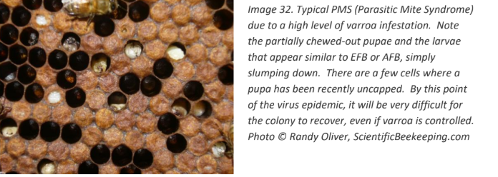

- Bees dying on emerging from cells - Bees with PMS will die at many stages including fully formed. Often will have tongues sticking out.
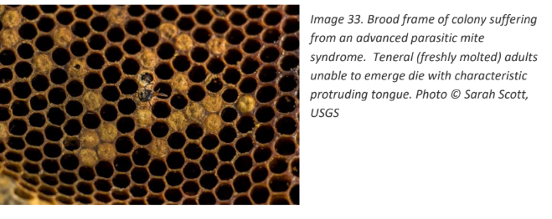

- Guanine deposits - From mite defecation, which appear like grains of coarse salt stuck to the sides of the cells. To view these deposits, hold the frame horizontally, similar to view AFB scales
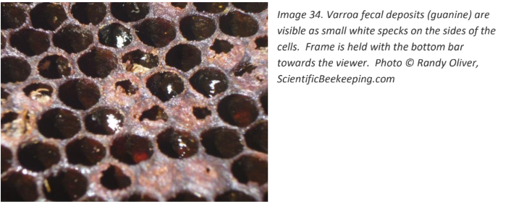

- Deformed wings - Wrinkled, deformed wings on young. They may be seen moving on the frames, or crawling outside the hive. You may not see bees with deformed wings as they might abandon the hive or get removed by other bees.
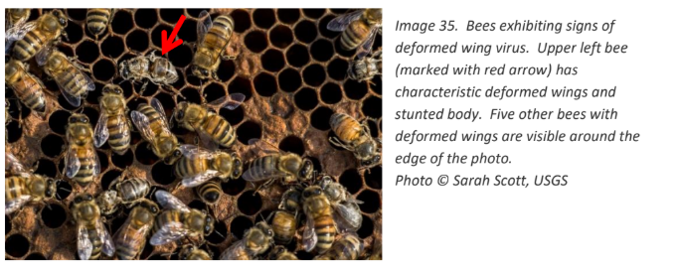

- Visible varroa mites - Most mites are underneath cappings, or on the underside of bees. Generally only visible when infestation is advanced.
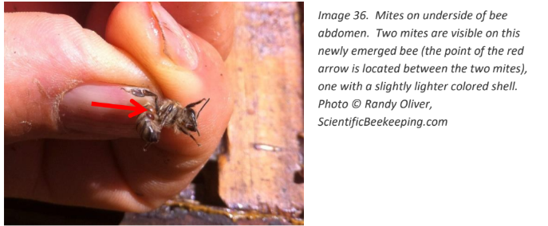

- Collapsing cluster size / absconding - The colony will get smaller, seeming like many bees just disappeared over a week. The telltale sign of the cause are the dead un-emerged adults with their tongues out with deformed wings. There will be white mite fecal deposits on the cell ceilings.

Suspect Parasitic Mite Syndrome if the following signs are present:
- Shotgun / patchy brood pattern
- Melted larvae
- Bees dying on emergence
- Guanine crystals on walls of cells
- Adult bees exhibiting deformed wings
- Chewed pupae
- Uncapped pupae

Parasitic Mite Treatment
Can only be prevented and controlled by managing the populations of varroa mites. Depending on the time of year and location, it may not be possible to save a colony that is showing signs of PMS. It is recommended to apply a treatment of miticide to kill the mites and prevent spread to other colonies, however in colder climates they most likely won’t survive the winter.

Beekeepers must have a strategy in place to manage the mite - those that do not will experience high mortality rates of their hives.

Small- scale beekeepers should be practicing integrated pest management (IPM) to manage varroa mites. This means that they are actively monitoring mite populations (generally with an alcohol wash or sugar roll), and should employ many physical, mechanical, and if necessary chemical controls.

🐝Honey Bee Viruses

Paralytic viruses
Such as Israeli acute paralysis virus, slow bee paralysis virus, chronic bee paralysis virus and acute bee paralysis virus can cause shivering wings, darkened hairless abdomens and thoraxes, and can progress to paralysis and death. Bees may drop to the bottom board, looking like a pesticide kill
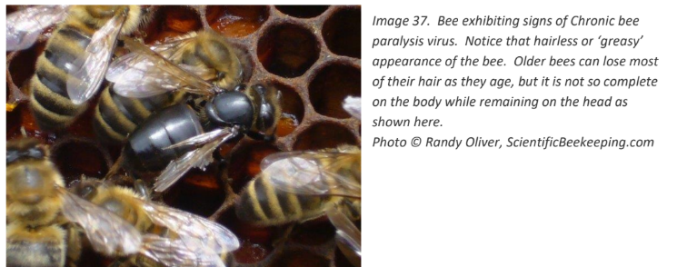

- The Sacbrood virus attacks larvae, resulting in a “shrunken head” appearance and failure to pupate. The larvae are observed on the floor of the cell with discolored or blackened heads angled upward.
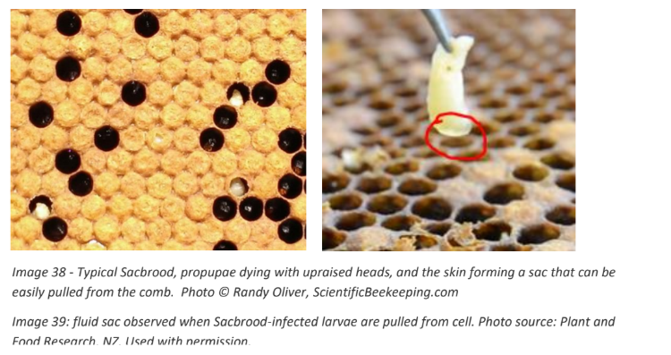

When the larvae are pulled out of the cell, there is an obvious fluid sac.

Treatment of Sacbrood
Generally will spontaneously resolve, and the colony does not experience significant setback. In severe cases, requeening is possible.

🐝Microsporidial Diseases: Nosema Infections

Two types of Nosema infections are possible, caused by the single-celled microsporidia Nosema apis and Nosema ceranae. The spores spread from bee to bee by feeding and fecal-oral transmission. The two Nosema diseases have different natural histories. Nosema apis tends to be worse in northern climates, and outbreaks occur more often in the fall and winter when bees cluster together to maintain hive warmth, while Nosema ceranae can be present year round.

Nosema signs
Bees wandering on ground outside colony, “K-wing”, yellow orange or brown fecal staining and poor growth of bees.
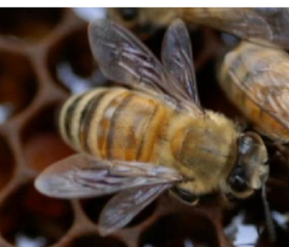

Nosema diagnosis
Must be confirmed by simple microscopy, either of a sample of adults or a one-by-one gut squashes.
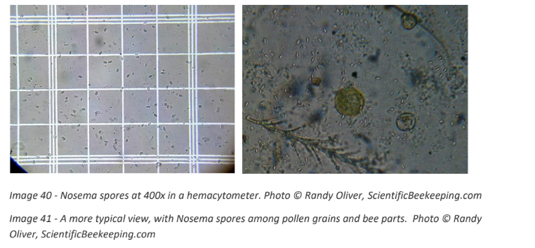

Nosema treatment
There is no approved treatment in the US but many colonies will clear the infection. If the case is chronic, requeening and food supplementation may be useful.

Chalkbrood
Caused by the Ascosphaera apis fungus that attacks larvae and pupae. This
condition is commonly seen in the spring and is more prevalent during rainy or wet weather, or after the colony has been chilled.

Chalkbrood signs
White fungal growth followed by white or black “mummies” or dead larvae or pupae.

Chalkbrood treatment
Reduce stress and use disease resistant bees. The hygienic nature of a strong colony will often clear the infection. In persistent cases, requeening and removal of diseased brood frames will help.

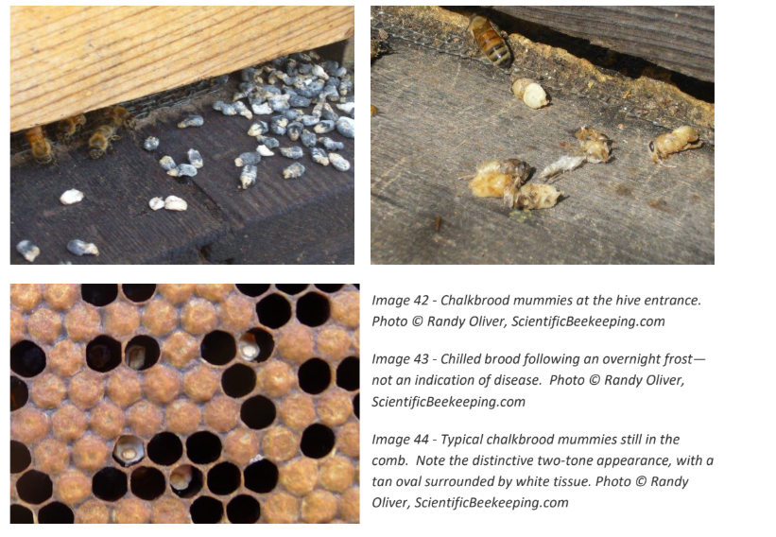

🐝 Parasites
Tracheal Mite Infestation
Small hive beetles
Tropilaelaps spp

Tracheal mite infestation
Can be difficult to recognize until the damage is severe. Mite females infest 1-2 day old bees and penetrate their thorax and trachea and lay eggs. The offspring mature and mate inside the trachea, causing damage obstruction.

Crowded colonies are at higher risk, and infestations tend to peak in the fall and winter when bees are clustered. Affected bees may develop “K-wing” however this is not unique to tracheal mite infestation. Confirmed with microscopic evaluation of affected bees.

Tracheal mite control
Resistant queens are the preferred method of control, but grease patties or menthol may also be used.

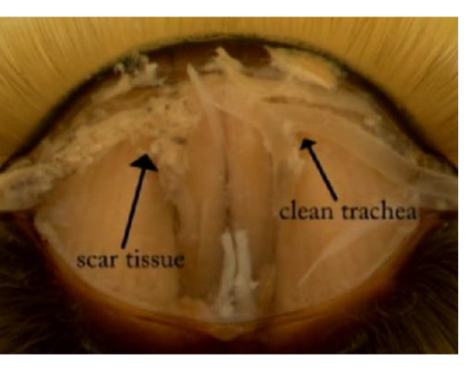

Small hive beetles
The females lay eggs in brood cells and their larvae feed on brood, honey, and pollen before leaving the hive to pupate in the surrounding ground and start the life cycle again. The beetle larvae excrement may ferment honey. The best way to control them is to have strong, healthy colonies that resist their infestation.

In northern climates beetles are usually indicative of another underlying disease weakening the colony.

Most beekeepers control beetles with trapping using a frayed fabric or a commercially available trap. Can also use entomopathogenic nematodes. Pesticides such as coumaphos and permethrin are available for use but can have detrimental effects on the honey bees and should be avoided if possible.

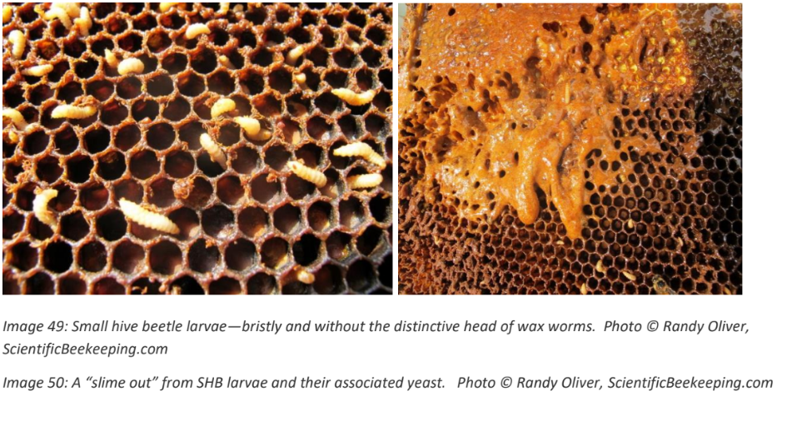

🐝 Other Health Conditions

Malnutrition
Weakens the bee immune system. Best diet is biodiverse natural diet.

Pesticide toxicity
Difficult to identify based on visual inspection. You may notice a large number of dead or dying bees at the front of the hive entrance. Should be properly reported.

Diploid drone syndrome (inbreeding)
This results from the queen mating with a close relative drone. The offspring are diploid, but they are homozygous at the sex locus. Despite being fertilized and diploid, the eggs don’t develop into worker bees because nurse bees detect the problem and destroy the egg. Usually news requeening - very rare condition.’

Overly hygienic hive
Normal brood is unnecessarily destroyed by overly hygienic workers. This resembles diploid drone syndrome in that the nurse bees cull the brood, but you can often view uncapped and chewed pupae.

Drone-laying queen
This occurs when the queen lays drone eggs in the worker cells. The pattern is chaotic and can produce excessive drones, which do not contribute to work. Usually needs requeening.

Laying worker
Normally the pheromones from the queen and brood inhibit ovary development in the worker bees, preventing them from laying. In the absence of these pheromones, inhibition is lost and one or more workers develop to the point that they can lay eggs. Because the workers never mate, the eggs are haploid and become drones.

Signs of a laying worker colony
The brood pattern is spotty, and will be all drone brood laid in worker cells (bullet-shapped). There are many eggs in a cell, and are poorly laid and attached to the sides of the cell.

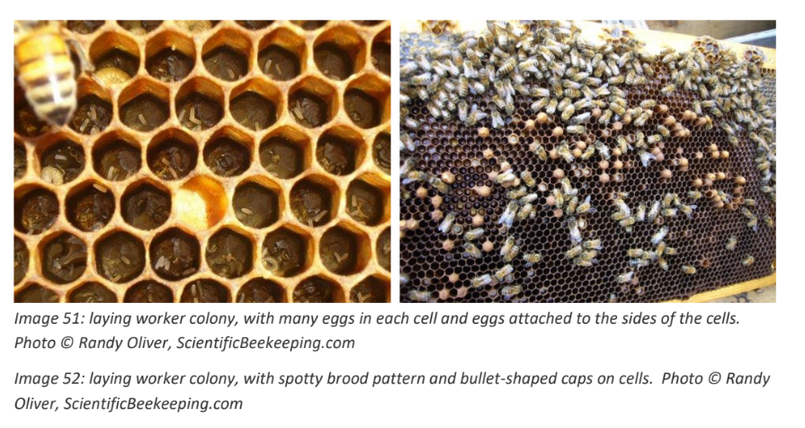

Treatment of a laying worker colony
Will likely show signs of disease, malnutrition, and pest invasion due to stress. This is a terminal condition. Shake the laying workers out of the colony and the equipment removed. They can be added to other colonies in the yard. Large laying worker colonies should be combined with a nuc or other colony using a newspaper combine.

Colony Collapse Disorder
A dead colony with no adult bees and no dead bee bodies but with a live queen, and usually honey and immature bees (brood) still present. Not caused by disease and unknown cause. Most research points to complex factors being involved.

Focus on improving health and habitat and use best management to reduce stress. An emergency response kit is available and protocols are available for sampling live bee and salt water solution and pollen.

Submission of Specimens for Diagnosis (USDA-ARS Bee Disease Diagnosis Service)
General Instructions
- Beekeepers, bee businesses, and regulatory officials may submit samples
- Samples are accepted from the United States and its territories only (not from other countries)
- Include:
  - A short description of the problem
  - Your name
  - Address
  - Phone number or email address
- There is no charge for this service
- For additional information, contact:
  - Sam Abban
  - Phone: (301) 504-8821
  - Email: samuel.abban@ars.usda.gov

How to Send Adult Honey Bees
- Send at least 100 bees
- If possible, select bees that are:
  - Dying
  - Recently dead
- Do not send decayed bees (not suitable for examination)
- Place bees in 70% ethyl, methyl, or isopropyl alcohol as soon as possible after collection
- Use leak-proof containers for packing
- Shipping notes:
  - USPS, UPS, and FedEx do not accept shipments containing alcohol
  - Pour off excess alcohol just before mailing
- Do NOT send bees dry (without alcohol)

How to Send Brood Samples
- Comb sample should be at least 2 x 2 inches
- Include as much dead or discolored brood as possible
- Do NOT include honey in the sample
- Packaging:
  - Use a paper bag or loosely wrap in paper towel or newspaper
  - Ship in a heavy cardboard box
- Avoid using:
  - Plastic
  - Aluminum foil
  - Waxed paper
  - Tin
  - Glass
  - (These materials promote decomposition and mold growth)
- If a comb cannot be sent:
  - Use a probe from a diseased larva cell
  - Wrap the probe in paper and send in an envelope
Send samples to:
Bee Disease Diagnosis Bee Research Laboratory 10300 Baltimore Ave. BARC-East Bldg. 306 Room 316 Beltsville Agricultural Research Center - East Beltsville, MD 20705

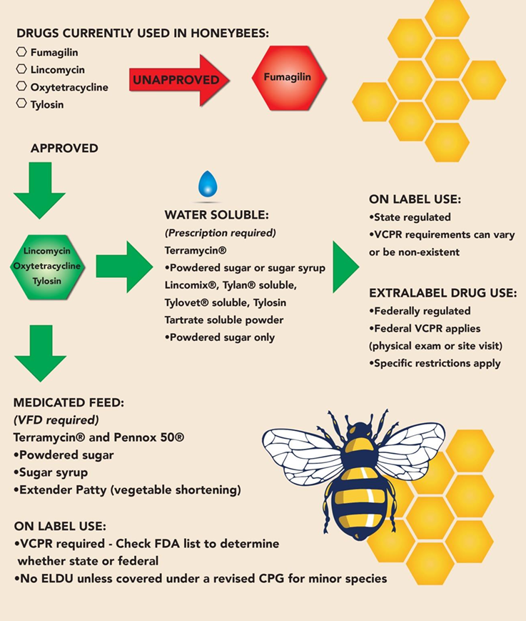

🐝 Honeybee Nutrition

• Macronutrients
• Nectar/honey - carbohydrates
• Pollen – protein and lipids
• Water
• Micronutrients
• Phytosterols
• phytochemicals

• Colonies can survive months on solely sugar diet (nectar)
• In order to rear new bees, colonies require
protein, lipids, sterols, vitamins, minerals
• Come from pollen

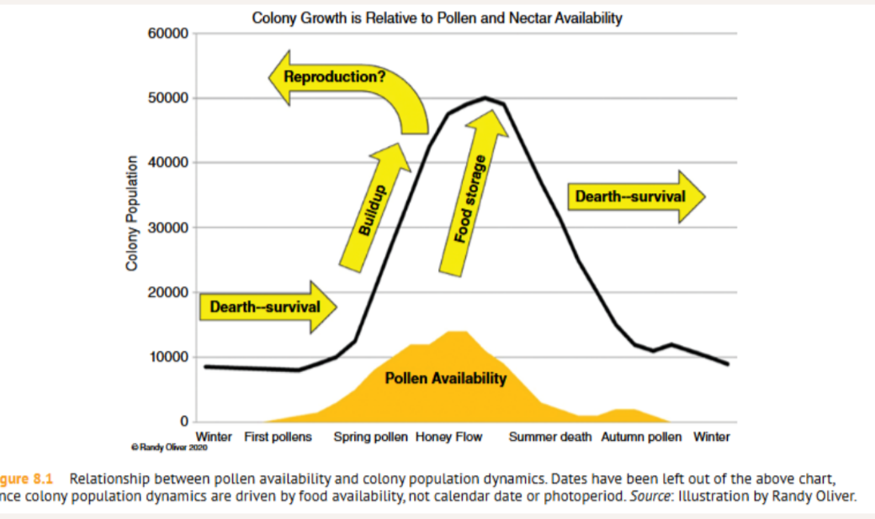

They prefer to forage within a 1kilometer radius

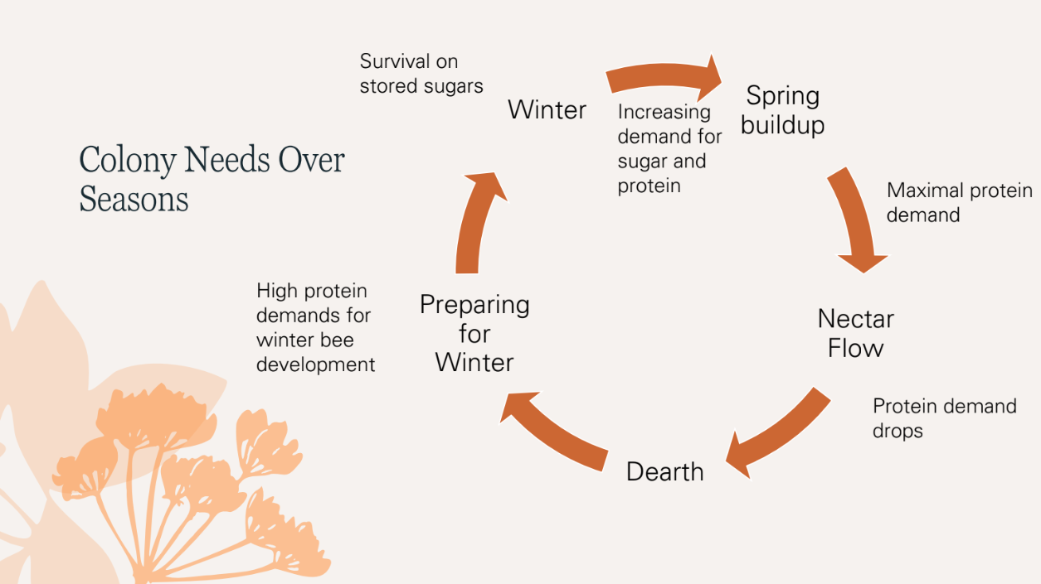

Nectar
Bees convert Nectar into honey using enzymes and dehydration of the nectar.
• Source of carbohydrates
• Converted into honey with enzymes
• Stored in cells
• Brood rearing
• Overwintering
Beekeepers must leave honey for the bees to eat over winter

Nectar to Honey
- 20-50% sugar concentration
- Surplus is dehydrated to 83%
- Higher proportion of glucose causes crystallization
- More dilute = fermentation

We will know when the honey is ready because it will be capped.
There are different types of sugar in honey. When glucose is higher than sucrose the honey will crystalize. If the honey crystalizes in the comb the bees will have a difficult time eating it. If the honey is too high in sucrose (runny) it will ferment. > this doesn’t really happen though.

If honey is marketed as a specific honey (orange blossom, blueberry, etc.) within 5 miles that is the only crop they are harvesting from.
In NJ its hard to label any honey other than wildflower bc within 5 miles there are so many different plants.

Workers require 4mg of sugar per day
• 10-12mg of sugar during flight and foraging
• Winter colonies require ~20-50kg of honey for survival

Pollen
The bee's main source of protein. Critical for raising brood. High quality and varied.

They need a variety of pollen to raise a healthy brood.

Bee bread is pollen stacked in the cells that will ferment over time. Bees will eat this. Protein is fed to larvae by nurse bees - after they emerge from the cell they don’t really eat pollen anymore.



High nutritional value pollen
Roseasia family - Apple (Malus domestica), Pear (Pyrus communis), Peach (Prunus persica), Cherry (Prunus spp.), Plum (Prunus domestica), Strawberry (Fragaria × ananassa), Raspberry (Rubus idaeus), Rose (Rosa spp.) Hawthorn (Crataegus spp.), Serviceberry (Amelanchier spp.)

Brassica family - Broccoli (Brassica oleracea var. italica), Cabbage (Brassica oleracea var. capitata), Kale (Brassica oleracea var. acephala), Cauliflower (Brassica oleracea var. botrytis), Brussels sprouts (Brassica oleracea var. gemmifera), Mustard greens (Brassica juncea), Arugula (Eruca vesicaria), Radish (Raphanus sativus), Turnip (Brassica rapa), Bok choy (Brassica rapa subsp. chinensis)

Nightshade family - Tomato (Solanum lycopersicum), Potato (Solanum tuberosum), Eggplant (Solanum melongena), Bell pepper (Capsicum annuum), Chili pepper (Capsicum spp.), Tobacco (Nicotiana tabacum), Petunia (Petunia spp.), Deadly nightshade (Atropa belladonna), Black nightshade (Solanum nigrum)

Poppy family - Opium poppy (Papaver somniferum), Corn poppy (Papaver rhoeas), Oriental poppy (Papaver orientale), California poppy (Eschscholzia californica), Iceland poppy (Papaver nudicaule), Celandine (Chelidonium majus), Prickly poppy (Argemone mexicana), Bloodroot (Sanguinaria canadensis), Dutchman’s breeches (Dicentra cucullaria), Bleeding heart (Lamprocapnos spectabilis)

Bees love mint plants!!

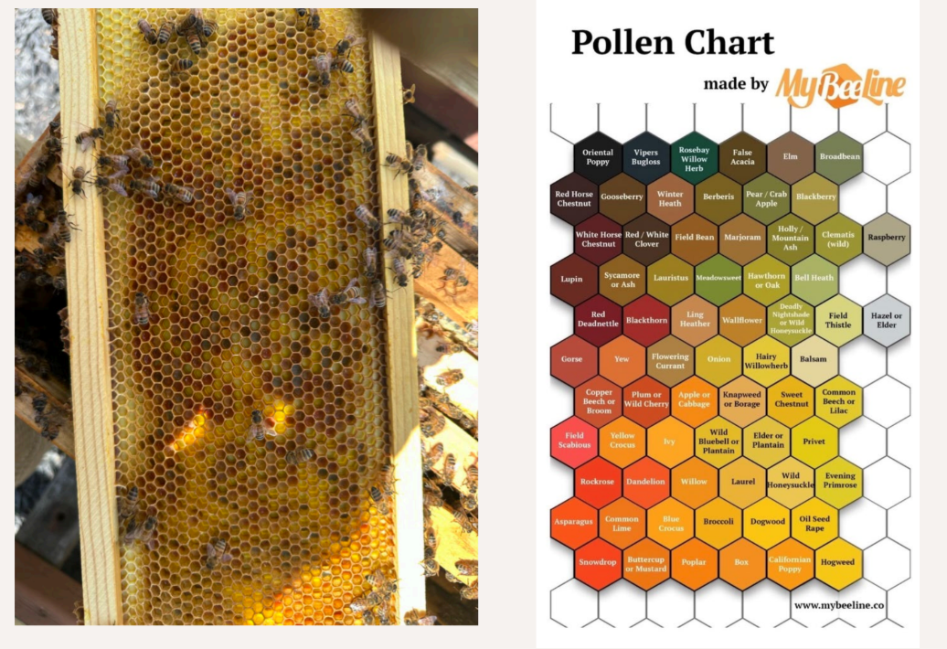

Lipids
Found in pollen
• Enhance learning and survival
Important for hormones, help make up the cell membranes, and provide winter support

Vitamins and minerals
From some pollen sources but also water sources - salt water, mud water, etcs

OMG I have that mineral stone Bobby gave me!!

Sterols and Other Phytochemicals

• Plant sterols are essential because insects cannot synthesize cholesterol
• Also component of major royal jelly protein 1

When Nutrition Goes Wrong
Bees can get dysentery - diarrhea caused by a diet imbalance. Usually bees will poo outside of the hive and you won’t even see it.

Toxic Nectars and Pollens
Bees usually know what to avoid
- Mountain laurel (native)
- Rhododendron (Rhododendron spp.)
- Azalea (Rhododendron spp.)
- Japanese pieris
- Spurge (various ornamental spurges)
- Foxglove
- Larkspur
- Butterfly weed (mild—sticky/toxic latex can affect small bees)
- Dogbane (native)

Royal Jelly
Royal jelly is a nutrient-rich secretion produced by young worker bees from their head glands and fed to all larvae briefly, but continuously to selected larvae to develop them into queen bees.
Composed of:
• Lipid-rich secretion from mandibular glands
• Protein-rich secretion from hypopharyngeal
glands
• Nectar

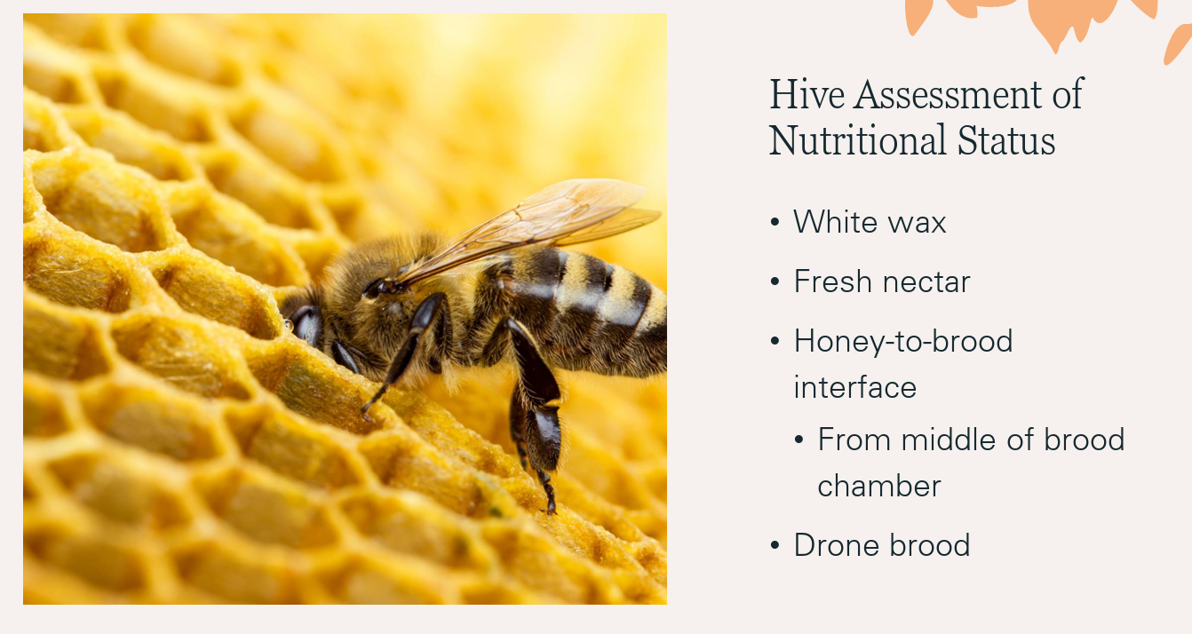

If they are able to make drones they are in a surplus b/c drones don’t do anything for the hive.

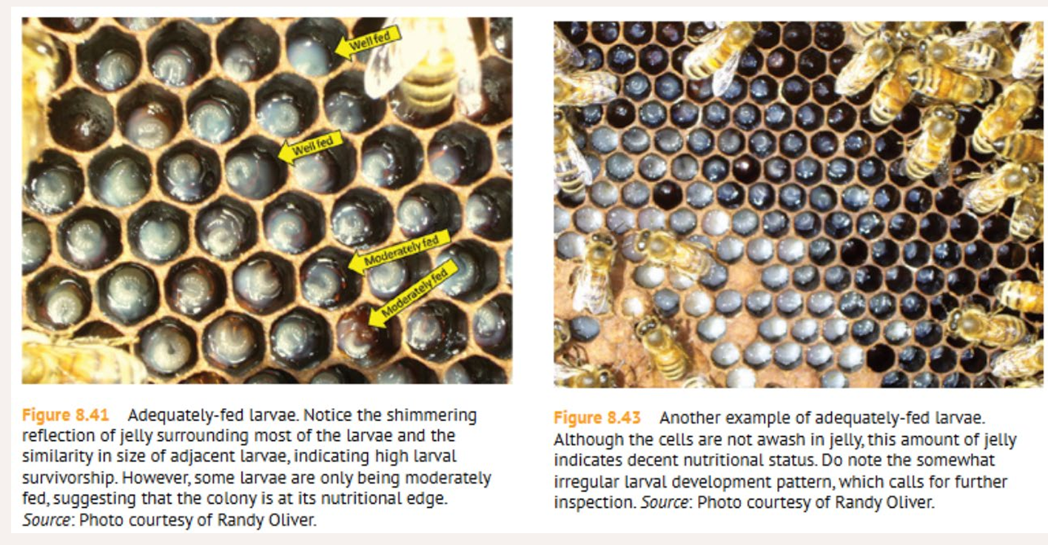

If we do supplement feed ~
Only white refined sugar! No molasses, brown sugar, etc.
• Sugar to water syrup
• 1:1 in spring
• 2:1 in fall
• Pollen patties

Best type of feeder is a hive top feeder (don’t have to open hive for this one)
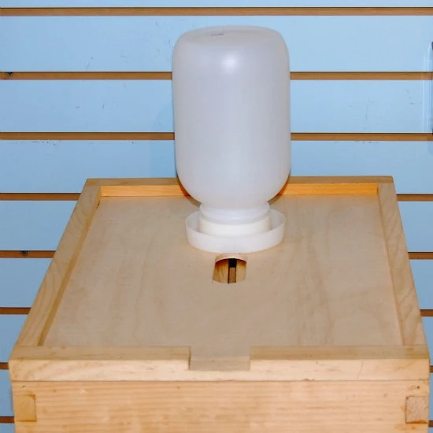

Or a Frame feeder
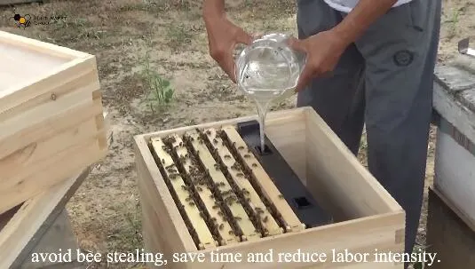

These will be able to prevent robbing

Or Pollen Patties - place directly on top of the frames, centered over the brood nest in the uppermost deep box. Can get moldy and dirty if bees end up not eating it

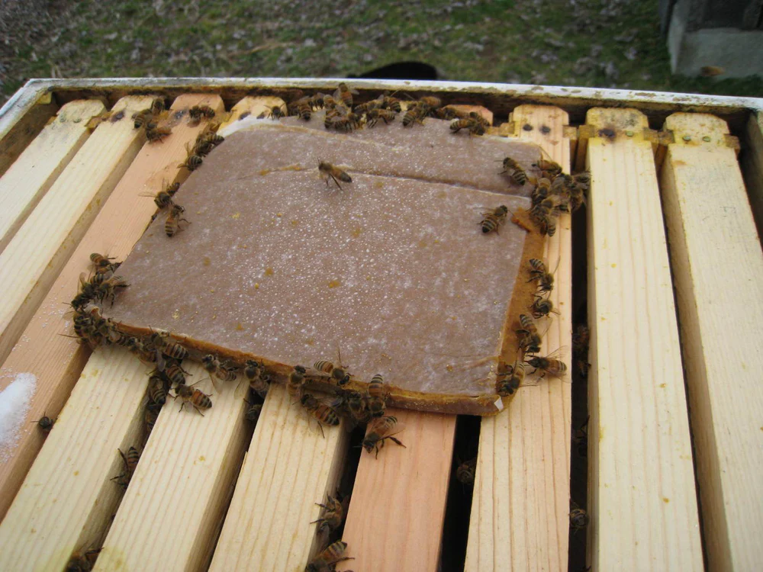

🐝 Setting up the Hive

Need to be near a water source
Facing South / South East. They wake up by the warmth of the sun
✨ Morning sun is important

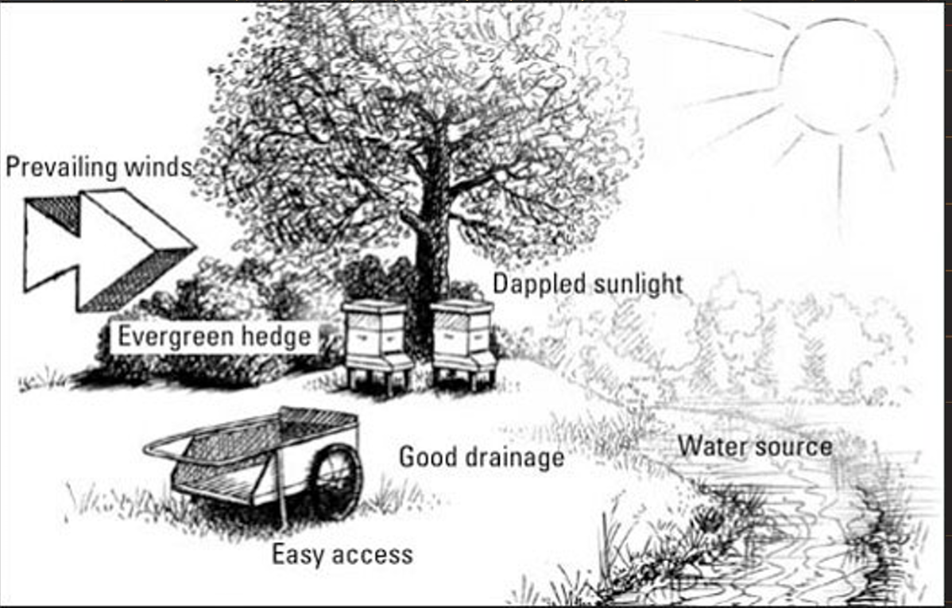

Barrier to prevent wind gusts

Slanted forward slightly to let rain and snow roll off and not backflow into the hive

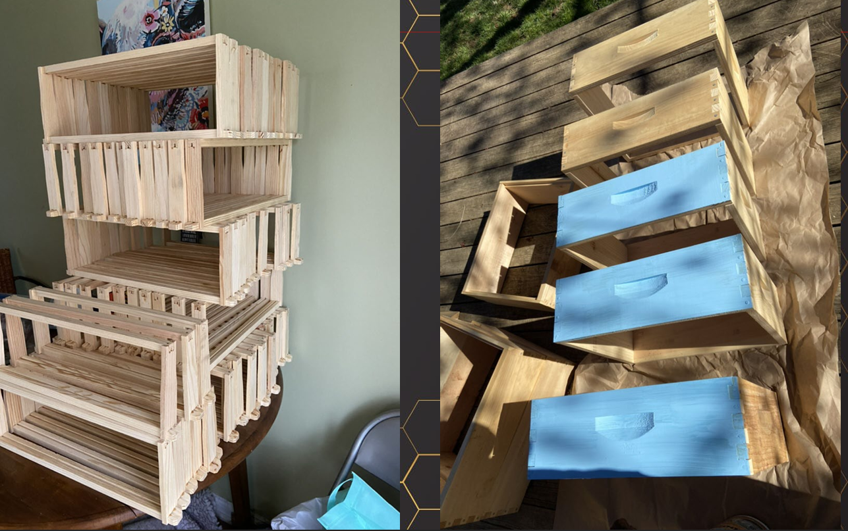

Boxes either need a wax dip or coated in paint to protect them from the elements

To get bees ~
- Can get them free from a swarm, but won’t know the health of the bees
- Buying a nucleus colony
  - Will likely be 5 frames of bees
  - Has a queen
  - Basically ready to go
  - Is a miniature hive
- Package - a package of bees that arrive in the mail
  - About 3-5 lbs of bees
  - A queen and some feed
  - Queen is not related to workers.
  - No comb
  - Will need intensive feed to get ready for the season
  - Often need the queen to be replaced b/c they’re not the healthiest

This is beeswax foundation queen excluder
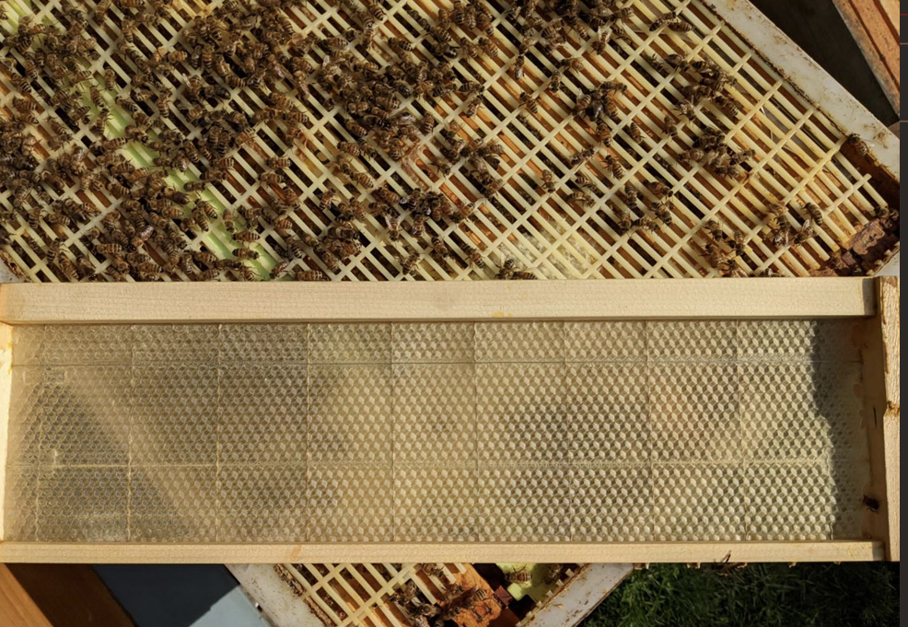

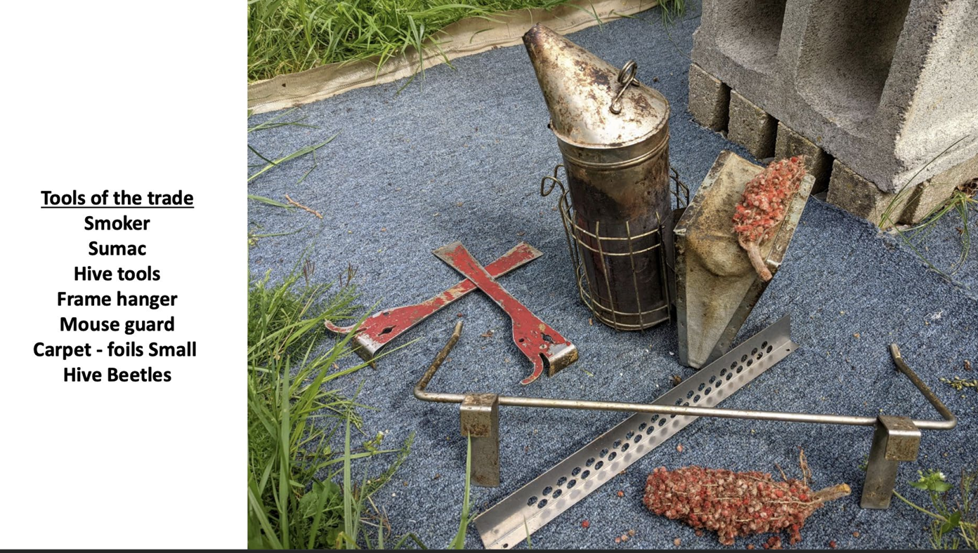

Smoker
Will calm the bees by masking an alarm pheromone. Makes them want to eat the honey and they get fat and sleepy.
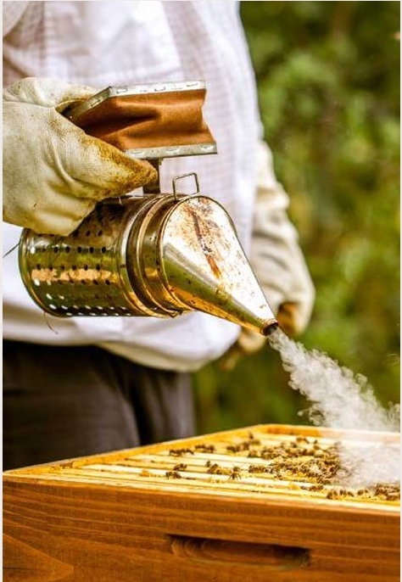

Been Brush
Brushes bees away safely
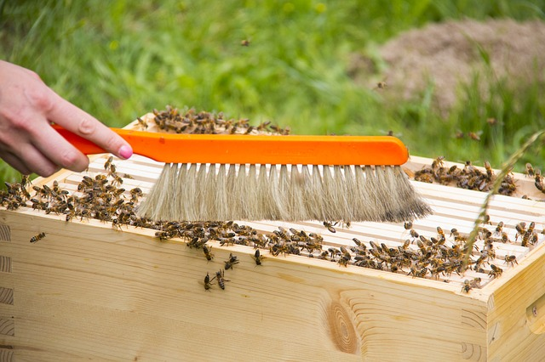

Hive Tool
Pry apart hive components. Things get sticky
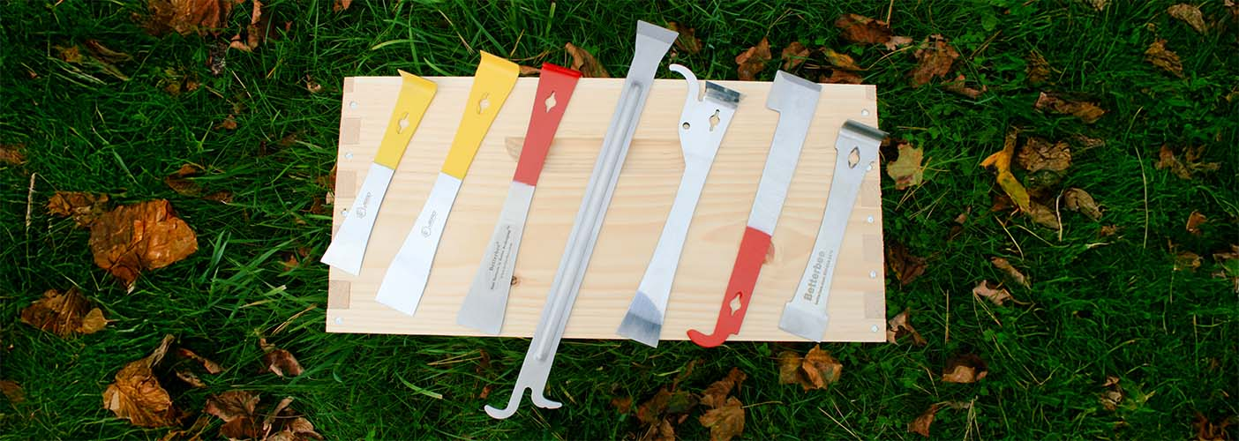

Frame Grip
Grab a frame and pick it up. Not all beekeepers like them
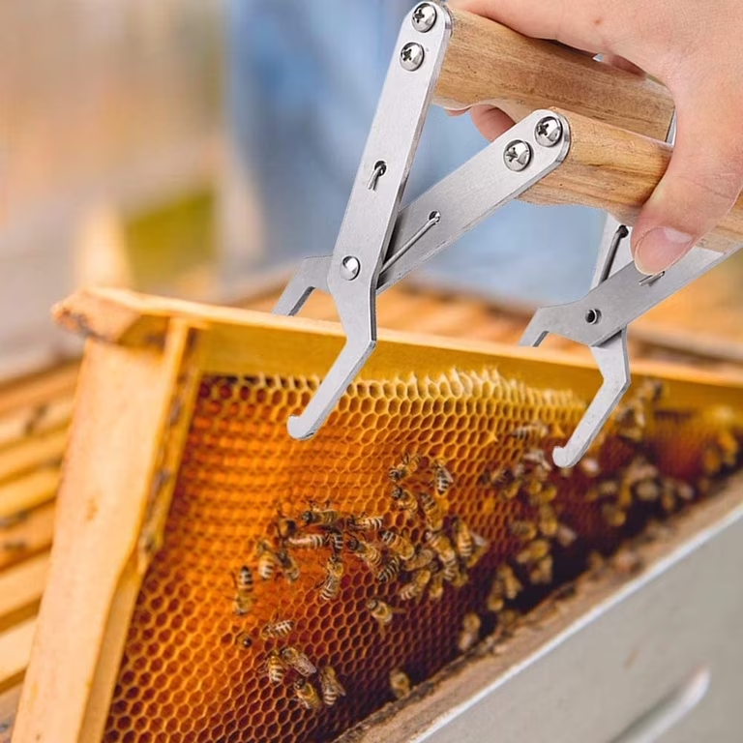

Queen Clip
Used to separate the queen.
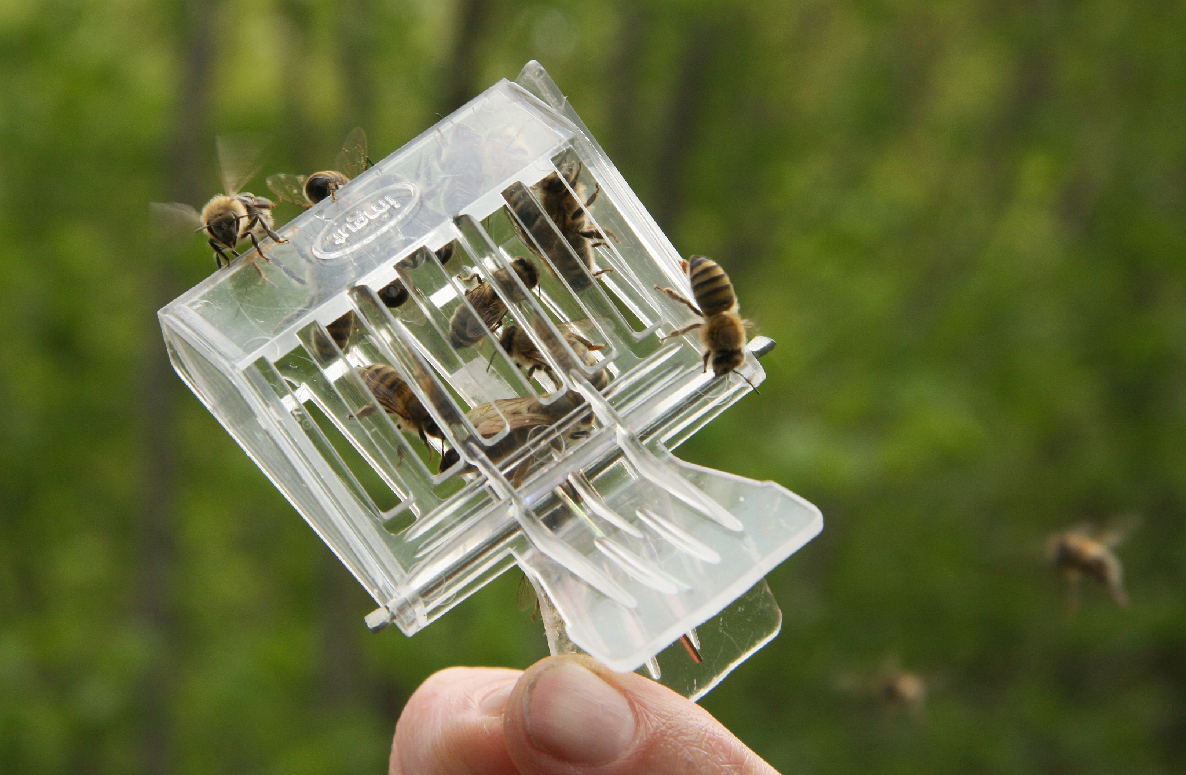

Crown of Thorns
Also used to trap a queen
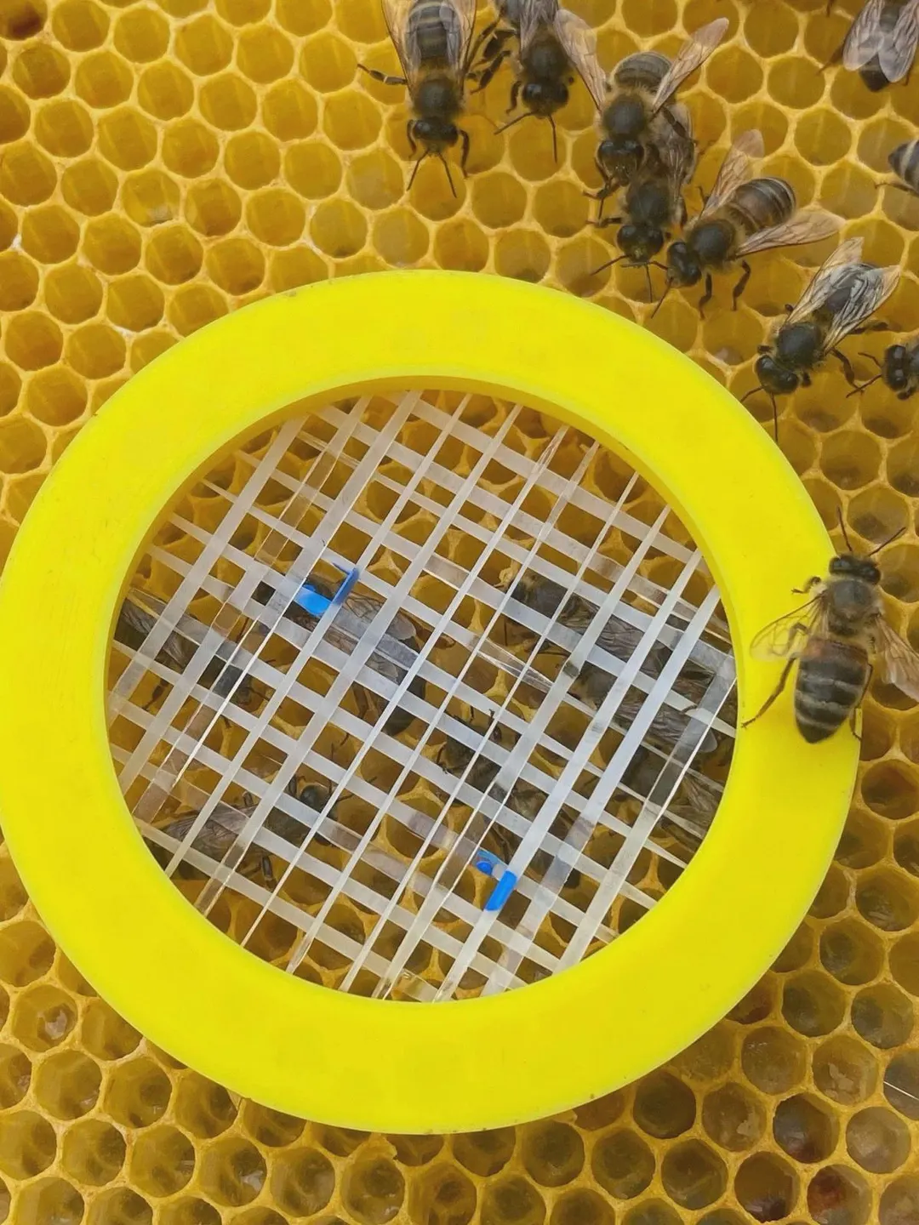

Paint Marker
Used to mark the queen

🐝Honey and Hive Products

Honey
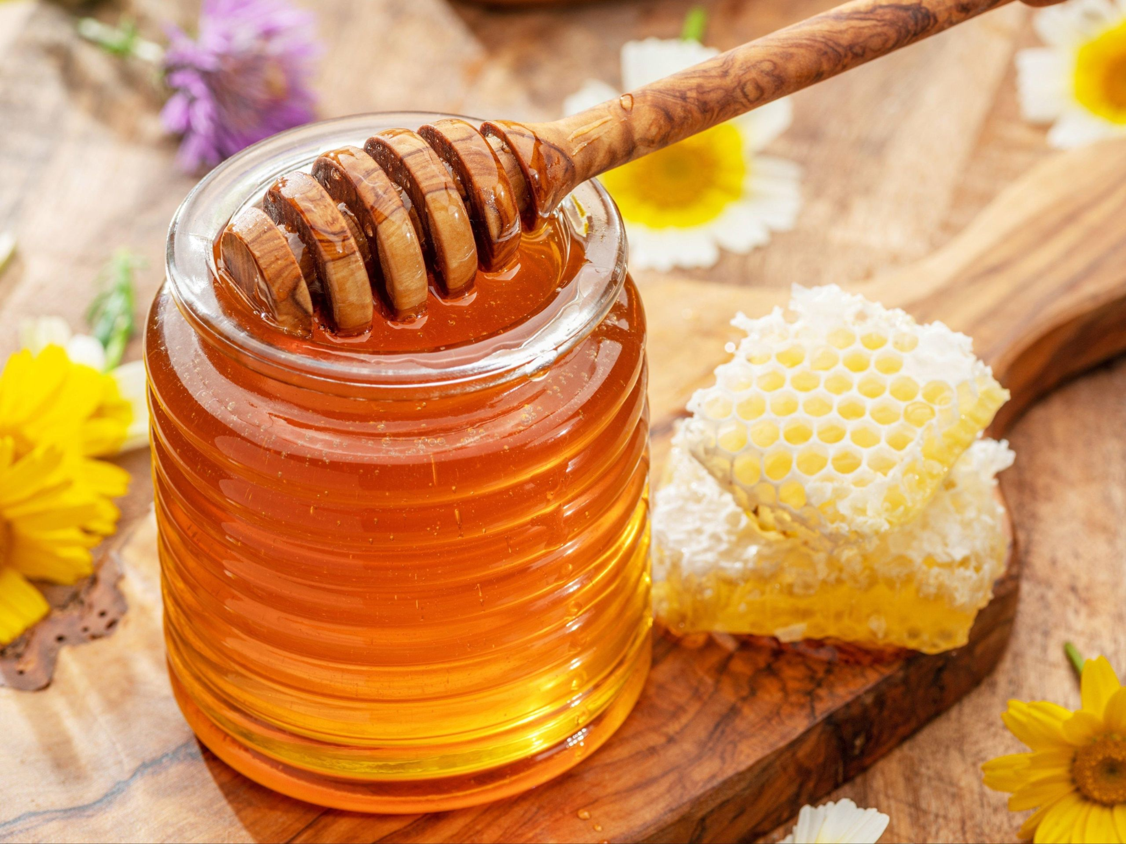
Concentrated floral sugars and enzymes.
Botanical origin - nectar or honeydew (insect plant exudate)
Bee-mediated transformation - invertase, glucose oxidase, diastase added by the bee
Physical ripening - cell capping at <20% water, pH 3.4-6.1, water activity ~0.6
Honey must be plant related in origin (the plant itself or an interaction with another animal)
Has to be regurgitated by a bee
And must be capped

Bees can make spotted lantern fly honey off of their honey dew production

From nectar to honey:
- Foraging - bees will draw nectar into its honey crop
- Enzymatic - Invertase hydrolyzes sucrose > fructose + glucose, glucose oxidase produces H2O2
- Transfer - Trophallaxis to house bees; further enzyme addition; antimicrobial peptides
- Dehydration - spread in cells; wing fanned to ~17-18% moisture (from 60-80%)
- Capping - cell sealed with wax once ripe - long term anaerobic storage

– - - what is in a jar of honey - -
Because honey has such a low water content it is antimicrobial. If the water content increases it will ferment.

— The 5% that makes honey —

Categories of Honey
Monofloral > 45% from one source
Distinct flavor and color - Orange blossom, clover, lavender, buckwheat. Not to be confused with backsweetened honey (vanilla, hot honey, lavender can be an added flavor)

Polyfloral = mixed flowers
No single botanical dominance. Most commercial table honey worldwide.

Honeydew
From insect plant exudates.
Dark, malty, low-fructose. Forest honey (fir, oak), pine honey, lantern fly honey.

Why does honey never go bad? It has low water content, and acidic pH, high osmotic pressure, and hydrogen peroxide (generated continuously by glucose oxidase upon dilution)

Buckwheat honey has super high antioxidants; dark honey typically has high antioxidant content

Storage
- Room temperature
- Glass container
- Indefinite shelf life
- Ultra filtered will remove beneficial pollen

Beeswax
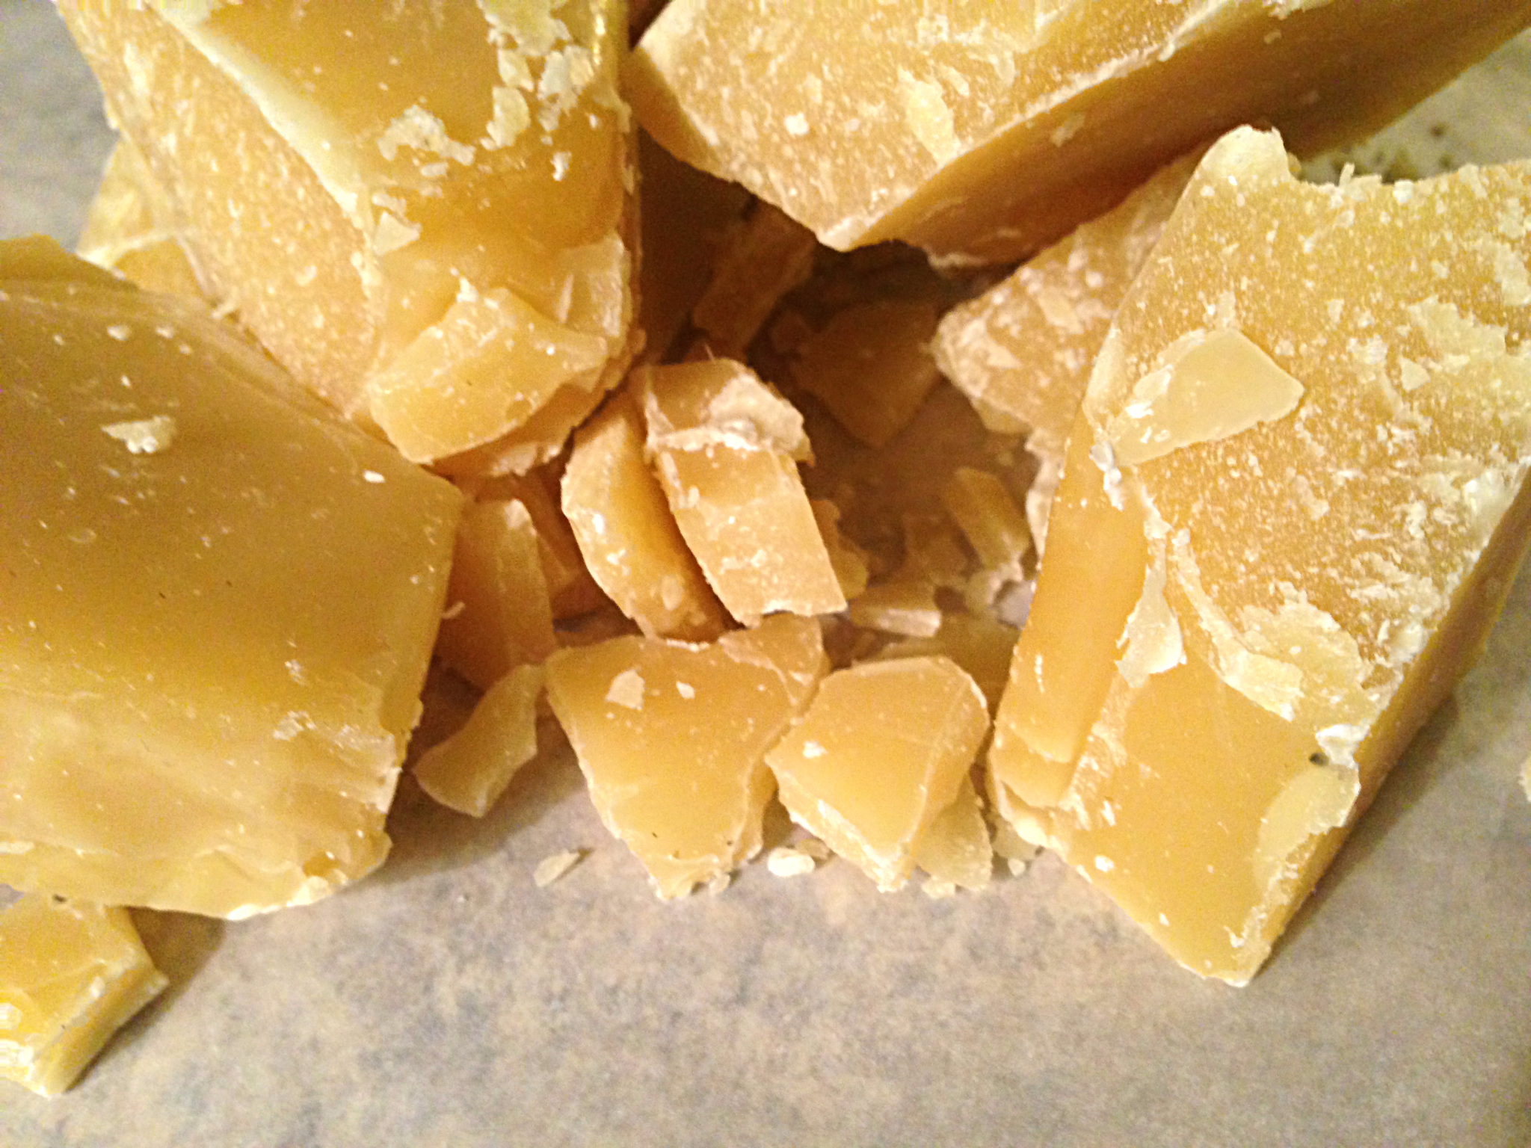
Wax ester polymer for comb structures

Secreted from the four pairs of wax glands on the abdomen.
Insoluble in water and makes a great storage vessel for honey.

Used for skin care, hair products, candles

Propolis
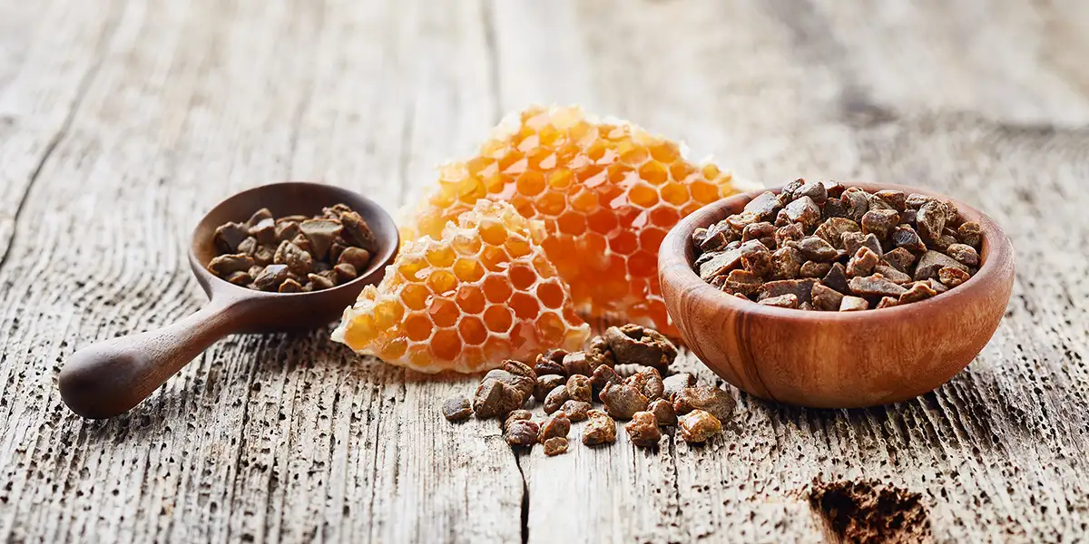
Plant resins and wax - antimicrobial sealant

“Bee glue”

What bees collect while they are out foraging. They use it to seal cracks around the hive and encase hive beetles or other predators like mice.

The composition of propolis varies greatly depending on the region.

Might be good for wound care, antimicrobial, burn care, anti-inflammatory, oral and dental care, and other potential uses.

Royal Jelly
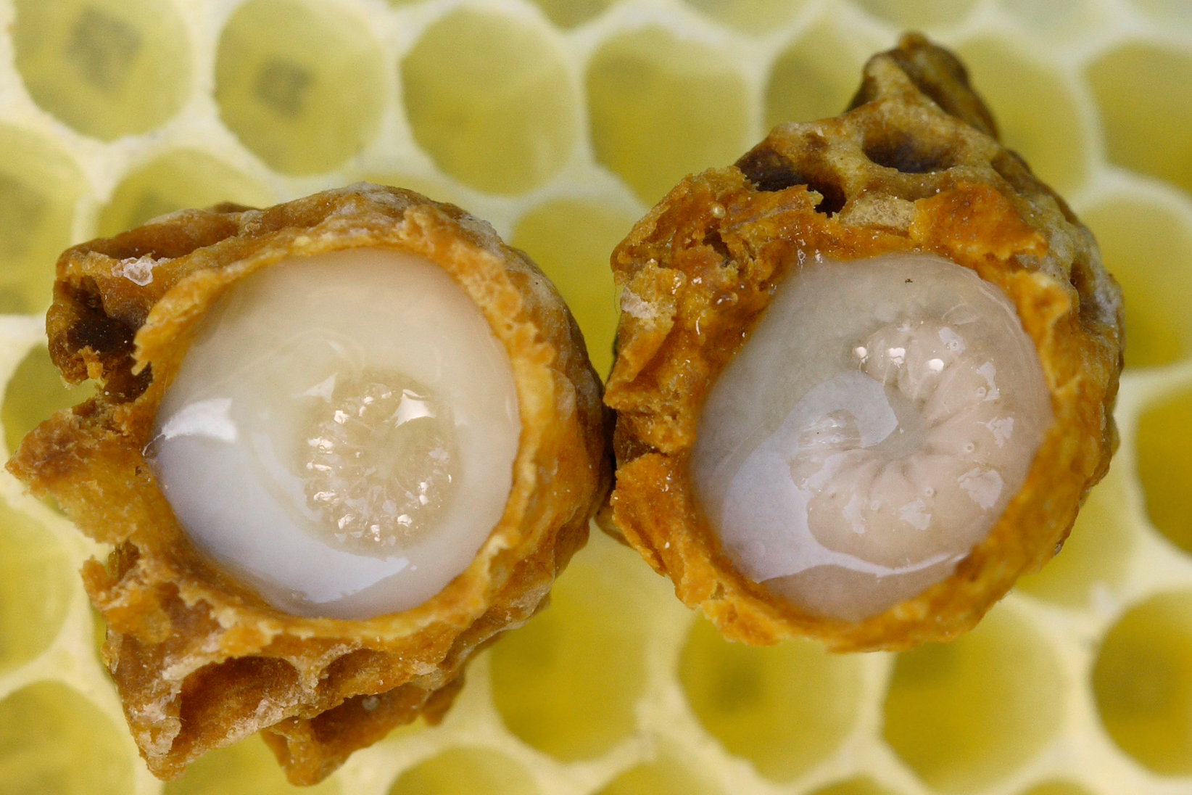
Hypopharyngeal gland larval fluid
A milky-white substance that comes from the glands of the nurse bees. Makes a queen bee if eaten.

Used as a tonic in traditional medicine across Asia and Europe. Marketed for perimenopause , fertility, immunity, and skin aging.

Tastes really bad and bees only produce an extremely small amount when they are creating a queen.

Can cause allergic reactions.

Bee Pollen
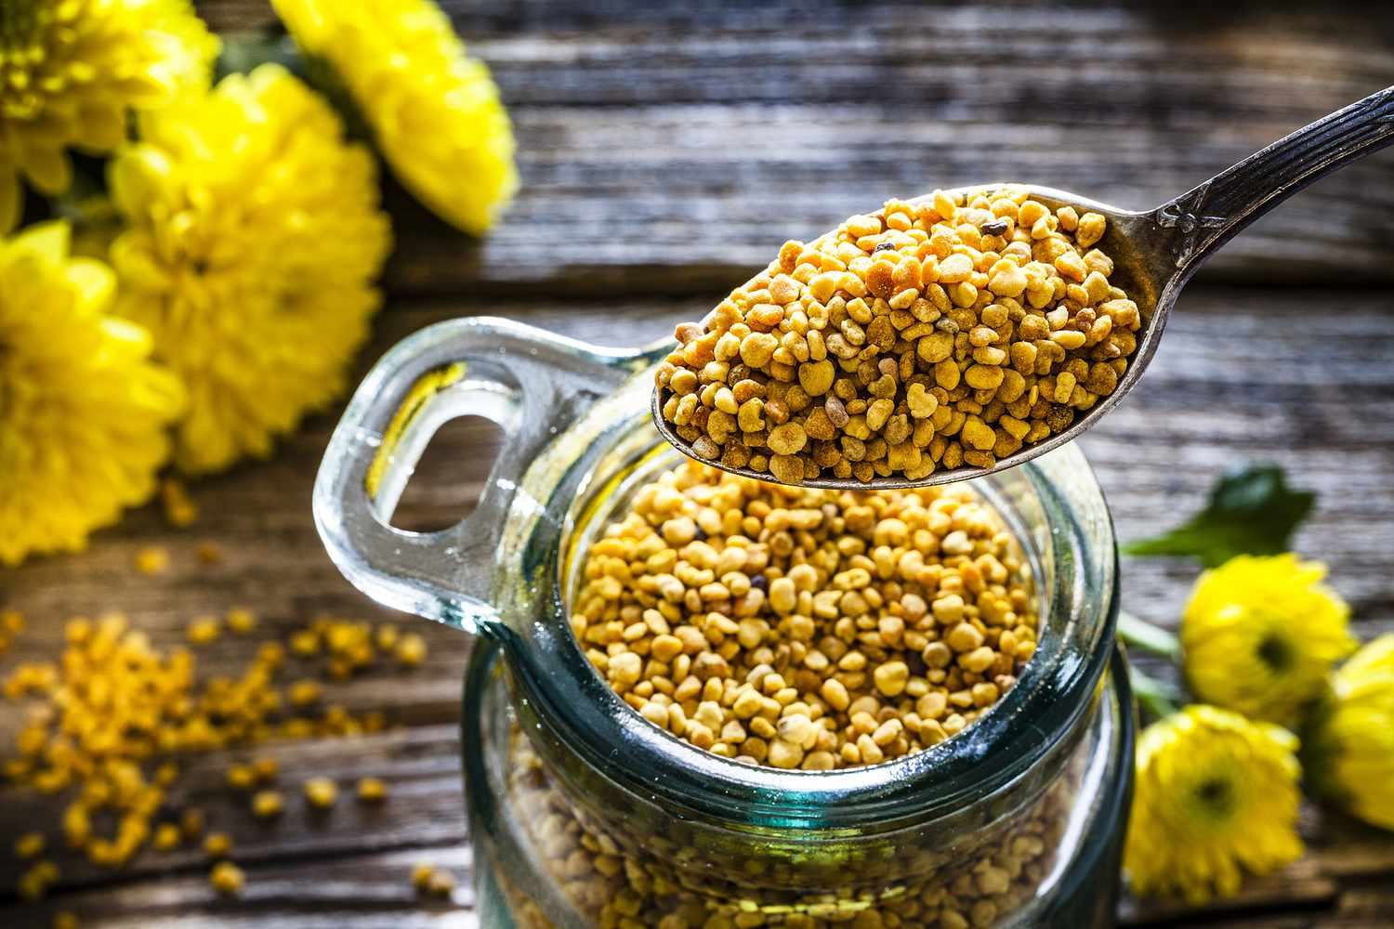
Plant pollen pack with nectar and enzymes from bee saliva. It has to be frozen or dehydrated for commercial sale because it will mold very quickly.

Seen as a “superfood”

Bee bread
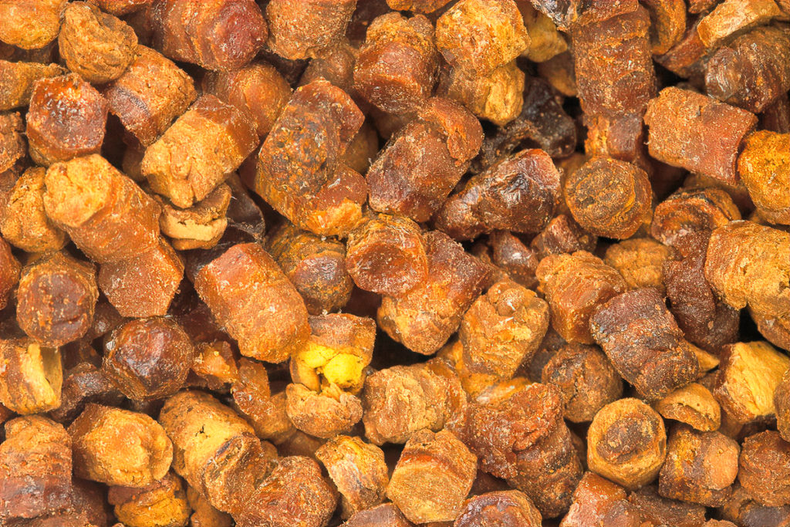
Fermented pollen the bees will store and feed to the developing worker bees.

Freshly deposited pollen will look like pollen granules, but the bee bread will look like stacks of discs.

Bee venom
Research shows that it can help with breast cancer, lyme disease, and other ailments.

🐝Bee Immunology

Bees have very unique social immunology based on their colony which is very unique to honey bees

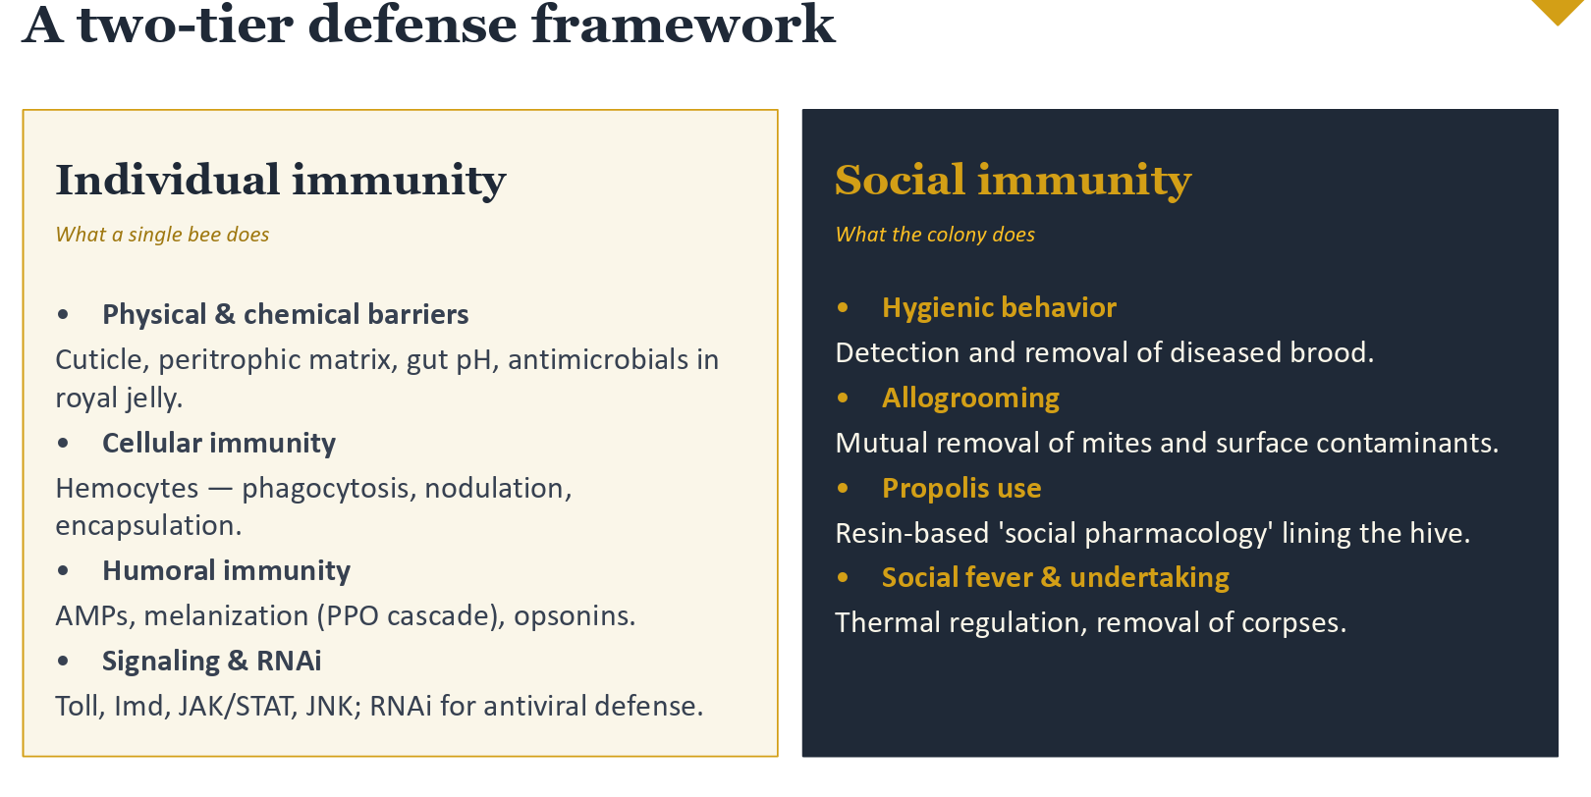

The first line of defence is their cuticle which keeps most diseases out as a barrier method. Varroa can break through this layer.

The gut lining prevents pathogens from getting through separating the food from bacteria.

They have gut microbiome, acidic gut, digestive enzymes, antimicrobial peptides in larval food all work to exclude pathogens.
Giving antibiotics to a hive will impact this microbiome

Hemolyph is the insect equivalent to blood and lymph. They do not have hemoglobin which is why it's not red. They do have immune cells.

If seeing dark spots on trachea or cuticles, this is a sign of mites. Here, the bees are trying to contain the pathogen.

